BEV Perception Paper Review

## Table of contents

* BEV explained
* List of papers
* Conclusion

## BEV Explained

BEV: BEV is the abbreviation for Bird-Eye-View for the autonomous driving industry. It is in the form of a grid with shape WxH, and a discreet height dimension Z.

BEV for Perception: BEV as a representational space to combine multi-sensory input, including the camera input, lidar input and radar input. It was first proposed by Tesla in Jul 2021 in its pure vision ADV solution. It was soon accepted by research institutions; many papers have been published since Dec 2021.

Advantage of BEV: BEV paradigm perception may seamlessly fuse multi-sensory input and boost final output performance.

Disadvantage of BEV: Using ViT as the backbone of the model, BEV based models are all facing heavy computing demand.

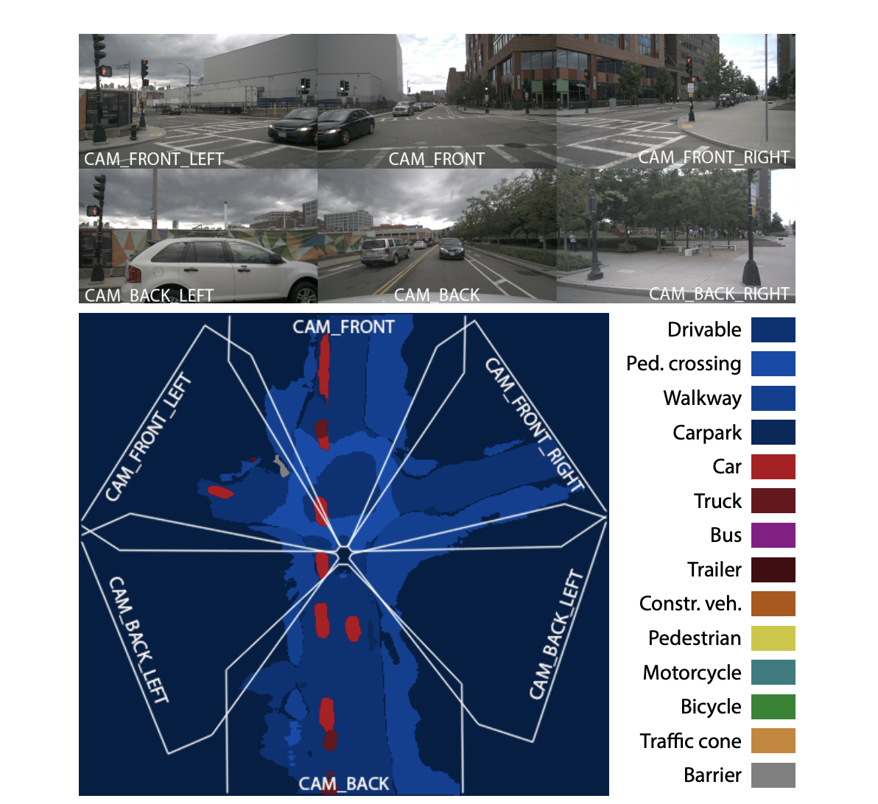

Example of Multi-camera BEV

## List of papers

### DETR: End-to-End object detection with Transformers

Abstract:

We present a new method that views object detection as a direct set prediction problem. Our approach streamlines the detection pipeline, effectively removing the need for many hand-designed components like a non-maximum suppression procedure or anchor generation that explicitly encode our prior knowledge about the task. The main ingredients of the new framework, called DEtection TRansformer or DETR, are a set-based global loss that forces unique predictions via bipartite matching, and a transformer encoder-decoder architecture. Given a fixed small set of learned object queries, DETR reasons about the relations of the objects and the global image context to directly output the final set of predictions in parallel. The new model is conceptually simple and does not require a specialized library, unlike many other modern detectors. DETR demonstrates accuracy and run-time performance on par with the well-established and highly-optimized Faster RCNN baseline on the challenging COCO object detection dataset. Moreover, DETR can be easily generalized to produce panoptic segmentation in a unified manner. We show that it significantly outperforms competitive baselines. Training code and pretrained models are available at <https://github.com/facebookresearch/detr>.

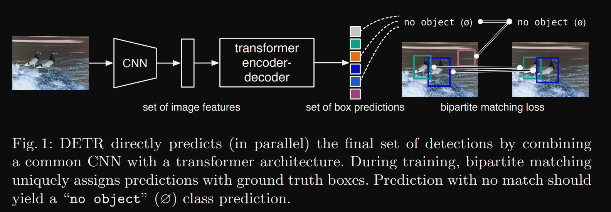

DETR model overall architecture

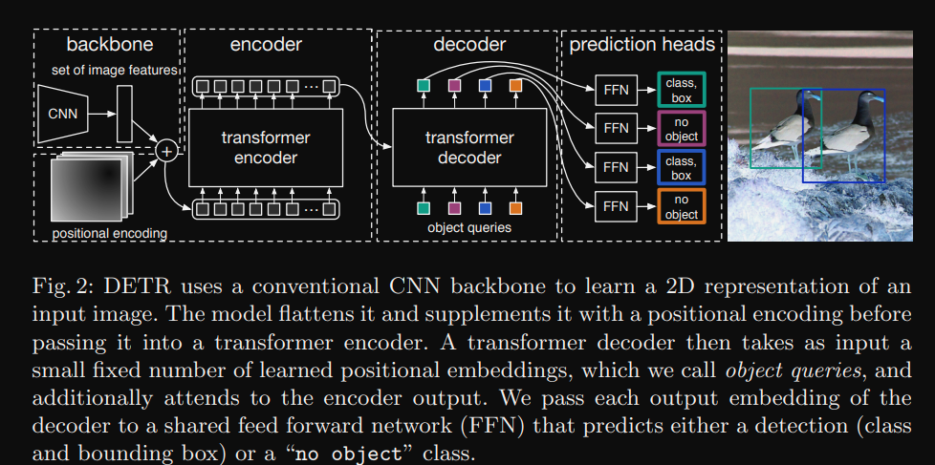

Detailed illustration of DETR model

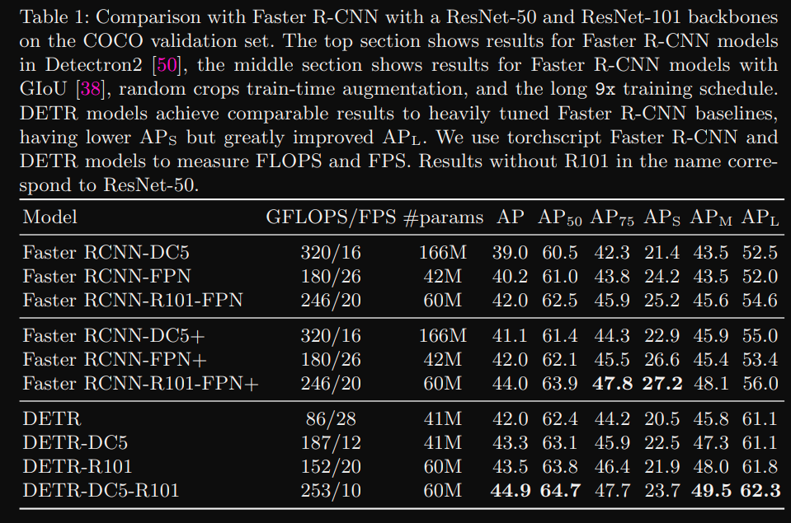

DETR Performance Table

Review:

A new design for object detection systems based on transformers and bipartite matching loss for direct set prediction. The first exploratory work using ViT for object detection. Achieved good overall performance on Coco dataset but is facing 2 major issues, 1st is the slow convergence issue, 2nd is the low performance on small and tiny objects. This is also an anchor-free method.

### DETR3D: 3D Object Detection from Multi-view Images via 3D-to-2D Queries

Abstract:

We introduce a framework for multi-camera 3D object detection. In contrast to existing works, which estimate 3D bounding boxes directly from monocular images or use depth prediction networks to generate input for 3D object detection from 2D information, our method manipulates predictions directly in 3D space. Our architecture extracts 2D features from multiple camera images and then uses a sparse set of 3D object queries to index into these 2D features, linking 3D positions to multi-view images using camera transformation matrices. Finally, our model makes a bounding box prediction per object query, using a set-to-set loss to measure the discrepancy between the ground-truth and the prediction. This top-down approach outperforms its bottom-up counterpart in which object bounding box prediction follows per-pixel depth estimation, since it does not suffer from the compounding error introduced by a depth prediction model. Moreover, our method does not require post-processing such as non-maximum suppression, dramatically improving inference speed. We achieve state-of-the-art performance on the nuScenes autonomous driving benchmark.

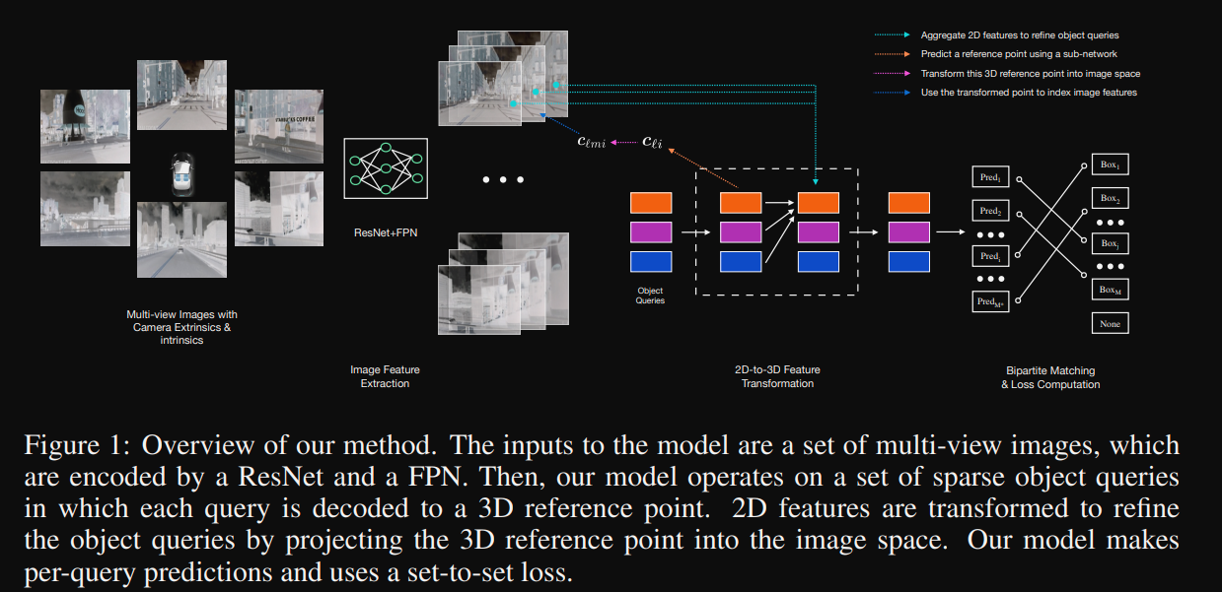

DETR3D model architecture

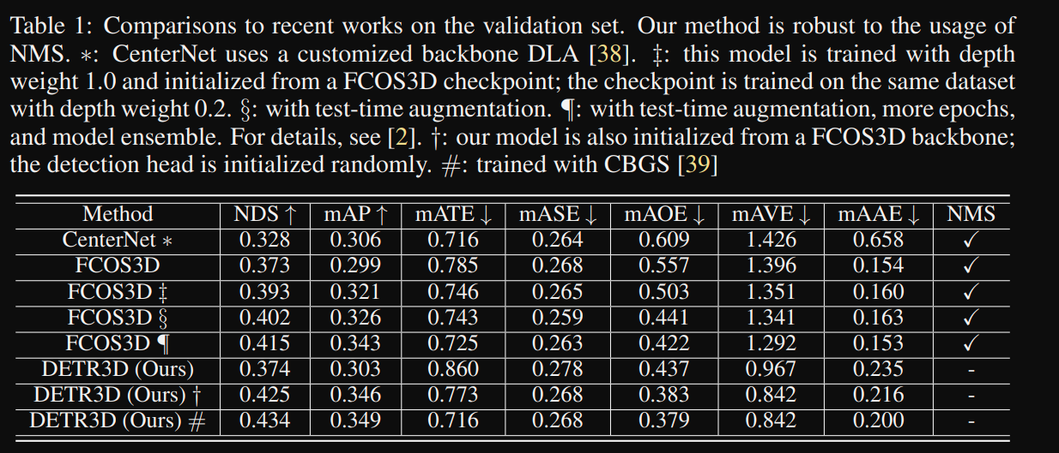

DETR3D performance table

Review: A follow-up work to apply the DETR model on multiview camera input for 3D object detection tasks. Major contribution of this work is using captures from multiple cameras instead of only the front-view camera.

### Deformable-DETR: Deformable Transformers for End-to-End Object Detection

Abstract:

DETR has been recently proposed to eliminate the need for many hand-designed components in object detection while demonstrating good performance. However, it suffers from slow convergence and limited feature spatial resolution, due to the limitation of Transformer attention modules in processing image feature maps. To mitigate these issues, we proposed Deformable DETR, whose attention modules only attend to a small set of key sampling points around a reference. Deformable DETR can achieve better performance than DETR (especially on small objects) with 10× less training epochs. Extensive experiments on the COCO benchmark demonstrate the effectiveness of our approach. Code is released at https:// github.com/fundamentalvision/Deformable-DETR.

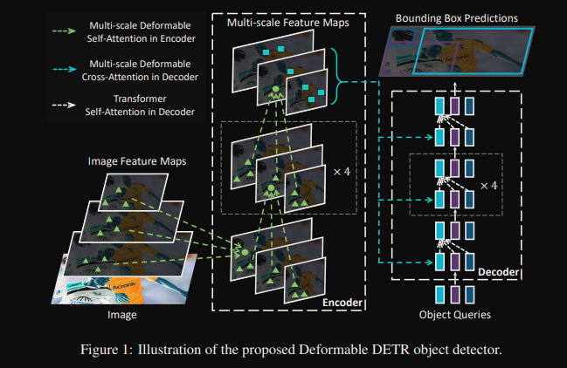

Deformable-DETR attention association

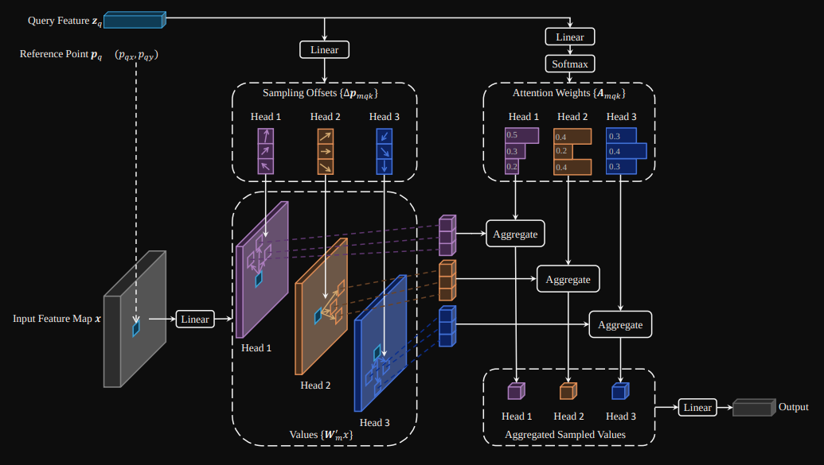

Deformable-DETR model architecture

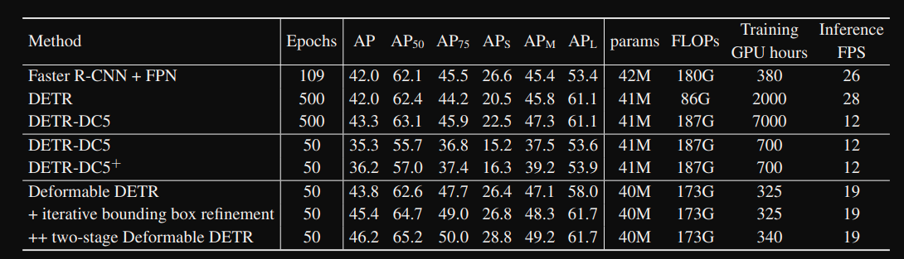

Deformable-DETR performance table on Coco 2027 dataset

Review:

Deformable-DETR heavily accelerated the training process of the original DETR model. The deformable concept comes from the deformable convolutional network. The prior knowledge of the deformable-DETR model is that objects in image will have correlation with only pixels nearby instead of all pixels globally, which reduces the overhead to converge for the attention layer of vision transformer.

### FCOS: Fully Convolutional One-Stage Object Detection

Abstract:

We propose a fully convolutional one-stage object detector (FCOS) to solve object detection in a per-pixel prediction fashion, analogue to semantic segmentation. Almost all state-of-the-art object detectors such as RetinaNet, SSD, YOLOv3, and Faster R-CNN rely on pre-defined anchor boxes. In contrast, our proposed detector FCOS is anchor box free, as well as proposal free. By eliminating the predefined set of anchor boxes, FCOS completely avoids the complicated computation related to anchor boxes such as calculating overlapping during training. More importantly, we also avoid all hyper-parameters related to anchor boxes, which are often very sensitive to the final detection performance. With the only post-processing non-maximum suppression (NMS), FCOS with ResNeXt-64x4d-101 achieves 44.7% in AP with single-model and single-scale testing, surpassing previous one-stage detectors with the advantage of being much simpler. For the first time, we demonstrate a much simpler and flexible detection framework achieving improved detection accuracy. We hope that the proposed FCOS framework can serve as a simple and strong alternative for many other instance-level tasks. Code is available at: tinyurl.com/FCOSv1

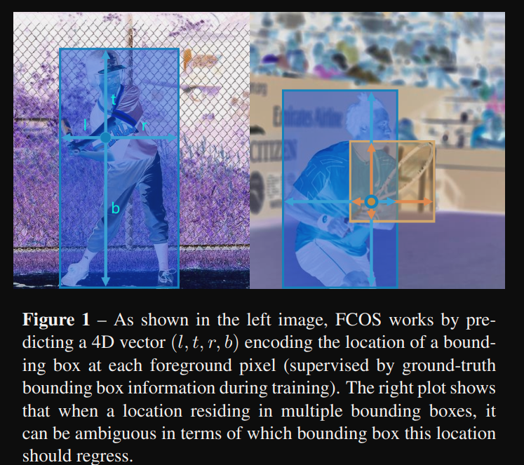

FCOS prediction illustration  
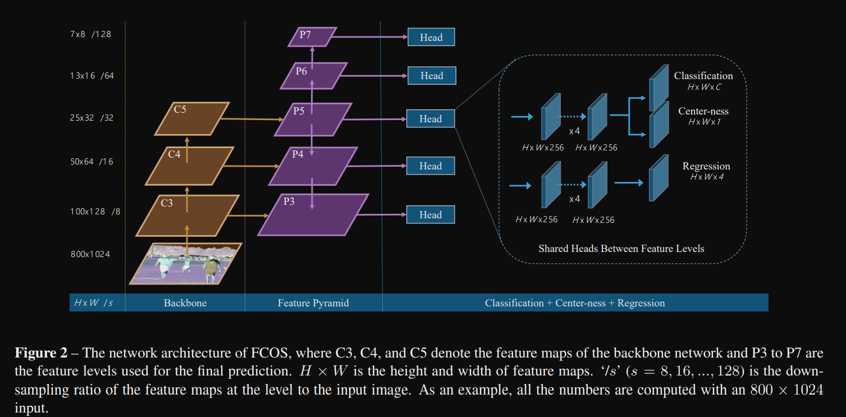

FCOS model architecture

Review:

FCOS is the first paper to convert object detection task to fully convolutional neural networks. It is also a anchor free method which accelerates detection pipeline much faster than anchor based methods. FCOS is the precursor work of FCOS3D.

### FCOS3D: Fully Convolutional One-Stage Monocular 3D Object Detection

Abstract:

Monocular 3D object detection is an important task for autonomous driving considering its advantage of low cost. It is much more challenging than conventional 2D cases due to its inherent ill-posed property, which is mainly reflected in the lack of depth information. Recent progress on 2D detection offers opportunities to better solving this problem. However, it is non-trivial to make a general adapted 2D detector work in this 3D task. In this paper, we study this problem with a practice built on a fully convolutional single-stage detector and propose a general framework FCOS3D. Specifically, we first transform the commonly defined 7-DoF 3D targets to the image domain and decouple them as 2D and 3D attributes. Then the objects are distributed to different feature levels with consideration of their 2D scales and assigned only according to the projected 3D-center for the training procedure. Furthermore, the center-ness is redefined with a 2D Gaussian distribution based on the 3D-center to fit the 3D target formulation. All of these make this framework simple yet effective, getting rid of any 2D detection or 2D-3D correspondence priors.

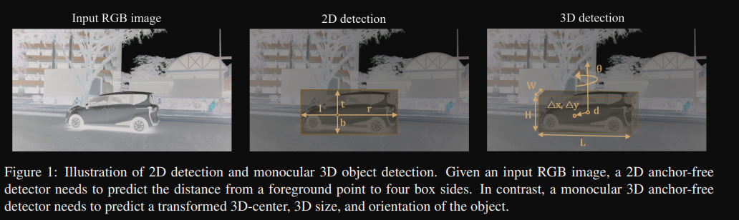

FCOS3D illustration of 2D task and 3D task

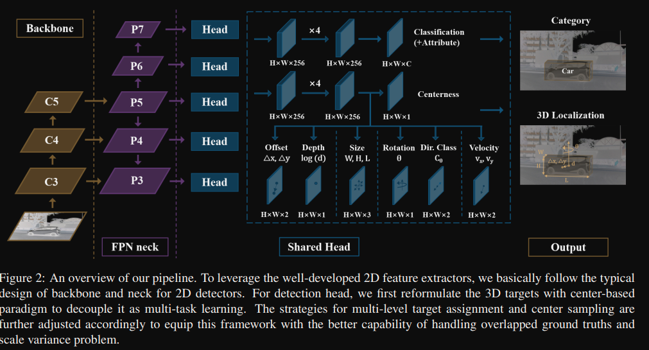

FCOS3D model architecture

Review:

FCOS3D is the adaptation of FCOS algorithm to 3D space.

### Lift-Splat-Shoot: ift, Splat, Shoot: Encoding Images From Arbitrary Camera Rigs by Implicitly Unprojecting to 3D

Abstract:

The goal of perception for autonomous vehicles is to extract semantic representations from multiple sensors and fuse these representations into a single “bird’s-eye-view” coordinate frame for consumption by motion planning. We propose a new end-to-end architecture that directly extracts a bird’s-eye-view representation of a scene given image data from an arbitrary number of cameras. The core idea behind our approach is to “lift” each image individually into a frustum of features for each camera, then “splat” all frustums into a rasterized bird’s-eyeview grid. By training on the entire camera rig, we provide evidence that our model is able to learn not only how to represent images but how to fuse predictions from all cameras into a single cohesive representation of the scene while being robust to calibration error. On standard bird’seye-view tasks such as object segmentation and map segmentation, our model outperforms all baselines and prior work. In pursuit of the goal of learning dense representations for motion planning, we show that the representations inferred by our model enable interpretable end-to-end motion planning by “shooting” template trajectories into a bird’s-eyeview cost map output by our network. We benchmark our approach against models that use oracle depth from lidar. Project page with code: https://nv-tlabs.github.io/lift-splat-shoot .

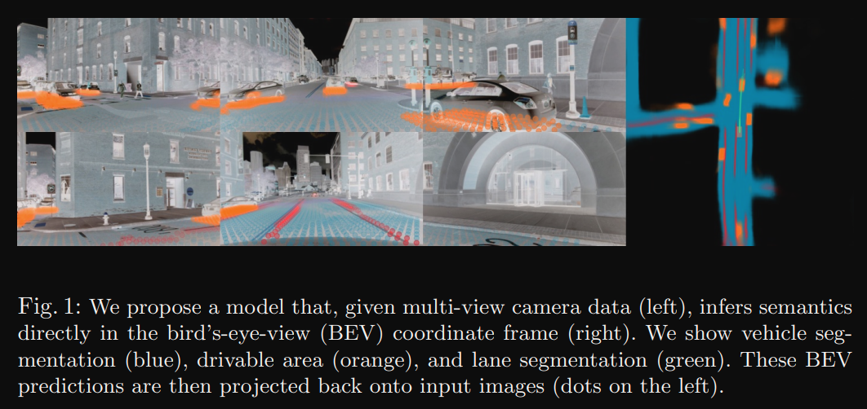

LSS demo

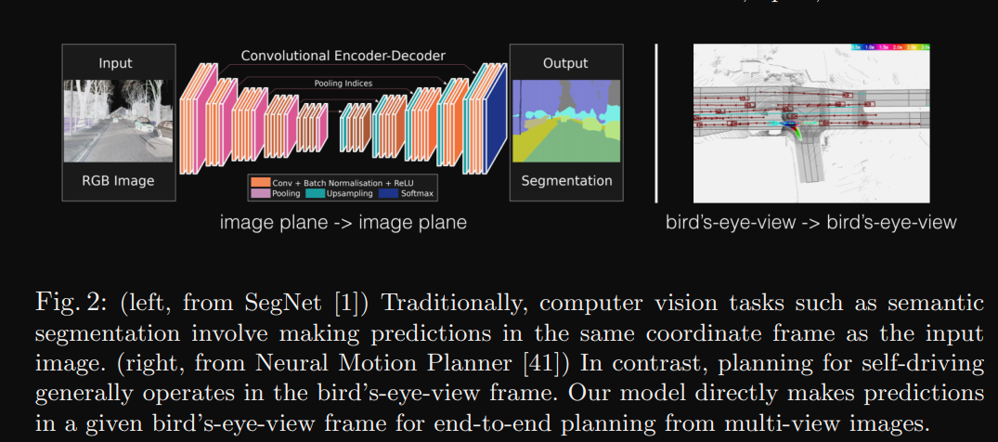

LSS comparison of same coordinate frame processing and BEV view

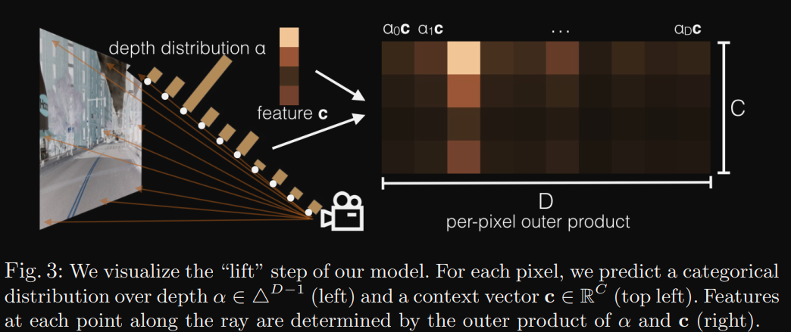

LSS illustration of Lift process

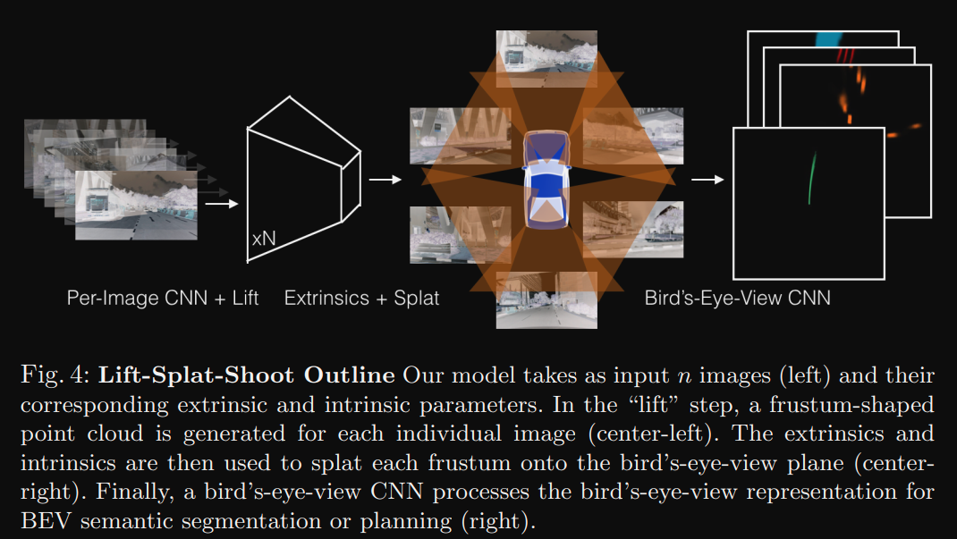

LSS the algorithm pipeline

Review:

LSS is the early stage model to utilize multiple camera input for perception tasks and serves as the foundation for many contemporary BEV based algorithms. LSS extends the single view perception task to multi-view perception. The contribution of LSS is it helps to remove the manual setting of excentric parameter alignment. While the limitation of LSS is the projection model to map 2D input to 3D space is much too mechanical. The projection module could be a data based method.

### VPN: Cross-view Semantic Segmentation for Sensing Surroundings

Abstract

Sensing surroundings plays a crucial role in human spatial perception, as it extracts the spatial configuration of objects as well as the free space from the observations. To facilitate the robot perception with such a surrounding sensing capability, we introduce a novel visual task called Cross-view Semantic Segmentation as well as a framework named View Parsing Network (VPN) to address it. In the cross-view semantic segmentation task, the agent is trained to parse the first-view observations into a top-down-view semantic map indicating the spatial location of all the objects at pixel-level. The main issue of this task is that we lack the real-world annotations of top-downview data. To mitigate this, we train the VPN in 3D graphics environment and utilize the domain adaptation technique to transfer it to handle real-world data. We evaluate our VPN on both synthetic and real-world agents. The experimental results show that our model can effectively make use of the information from different views and multi-modalities to understanding spatial information. Our further experiment on a LoCoBot robot shows that our model enables the surrounding sensing capability from 2D image input.

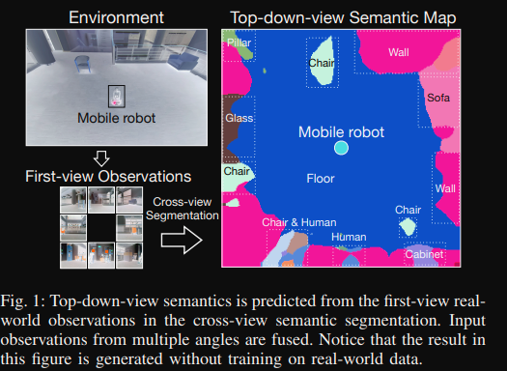

VPN illustration of multi-camera input

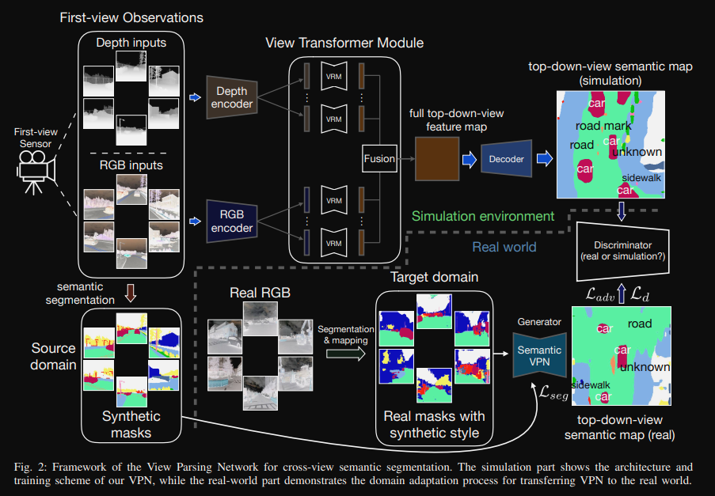

VPN illustration of model architecture

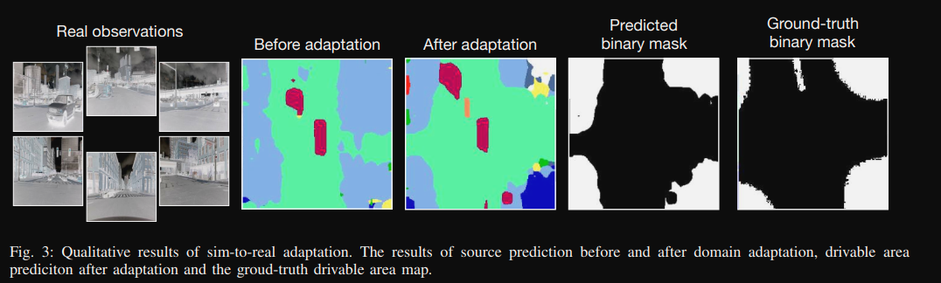

Qualitative example of VPN

Review:

VPN is the first algorithm to utilize surrounding cameras in semantic segmentation tasks, even though its designed for robots control tasks, the insight behind has inspired many follow-up works to take multi-camera capture as input. This work serves as the root of recent popularity of BEV based method. VPN also take advantage of simulator data for boost performance of real world detection tasks, which is a example of early application of sim2real methods.

### CenterPoint: Center-based 3D Object Detection and Tracking

Abstract

Three-dimensional objects are commonly represented as 3D boxes in a point-cloud. This representation mimics the well-studied image-based 2D bounding-box detection but comes with additional challenges. Objects in a 3D world do not follow any particular orientation, and box-based detectors have difficulties enumerating all orientations or fitting an axis-aligned bounding box to rotated objects. In this paper, we instead propose to represent, detect, and track 3D objects as points. Our framework, CenterPoint, first detects centers of objects using a keypoint detector and regresses to other attributes, including 3D size, 3D orientation, and velocity. In a second stage, it refines these estimates using additional point features on the object. In CenterPoint, 3D object tracking simplifies to greedy closest-point matching. The resulting detection and tracking algorithm is simple, efficient, and effective. CenterPoint achieved state-of-theart performance on the nuScenes benchmark for both 3D detection and tracking, with 65.5 NDS and 63.8 AMOTA for a single model. On the Waymo Open Dataset, CenterPoint outperforms all previous single model methods by a large margin and ranks first among all Lidar-only submissions. The code and pretrained models are available at <https://github.com/tianweiy/CenterPoint>

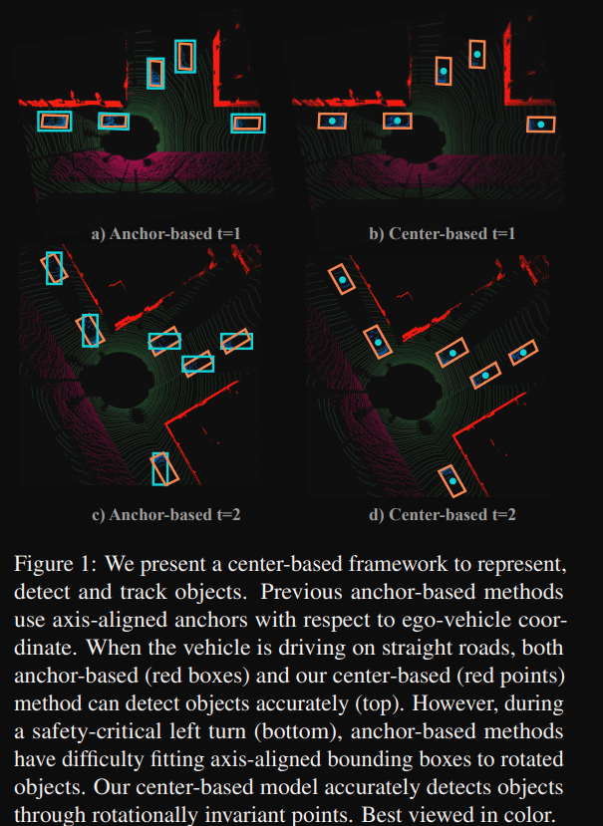

CenterPoint representation

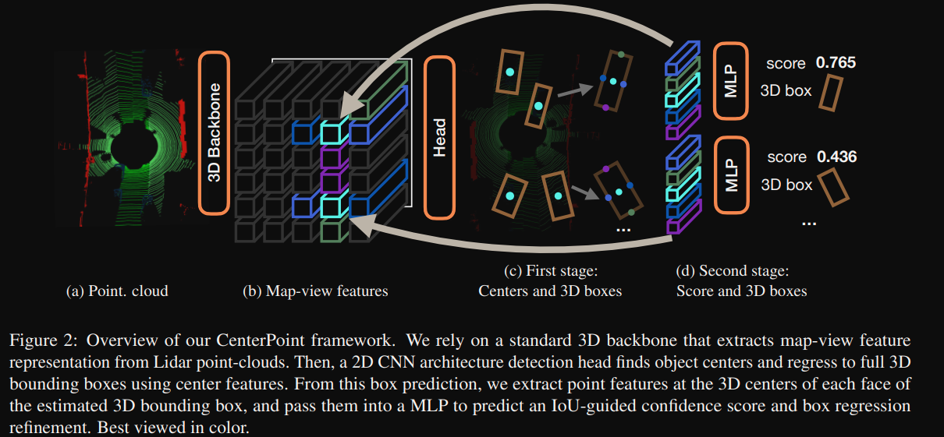

CenterPoint model architecture

Review:

CenterPoint first proposed to represent objects in 3D space in the form of center, rotation and edge length in x, y, z axis. This is also a early stage work that has defined a standard method to handle object detection tasks. Detecting object in the form of keypoint detection task helps alleviate the error from rotation, it also helps in reducing the error by refinement of relative positions.

### HDMapNet: An Online HD Map Construction and Evaluation Framework

Abstract:

Constructing HD semantic maps is a central component of autonomous driving. However, traditional pipelines require a vast amount of human efforts and resources in annotating and maintaining the semantics in the map, which limits its scalability. In this paper, we introduce the problem of HD semantic map learning, which dynamically constructs the local semantics based on onboard sensor observations. Meanwhile, we introduce a semantic map learning method, dubbed HDMapNet. HDMapNet encodes image features from surrounding cameras and/or point clouds from LiDAR, and predicts vectorized map elements in the bird’s-eye view. We benchmark HDMapNet on nuScenes dataset and show that in all settings, it performs better than baseline methods. Of note, our camera-LiDAR fusion-based HDMapNet outperforms existing methods by more than 50% in all metrics. In addition, we develop semantic-level and instance-level metrics to evaluate the map learning performance. Finally, we showcase our method is capable of predicting a locally consistent map. By introducing the method and metrics, we invite the community to study this novel map learning problem.

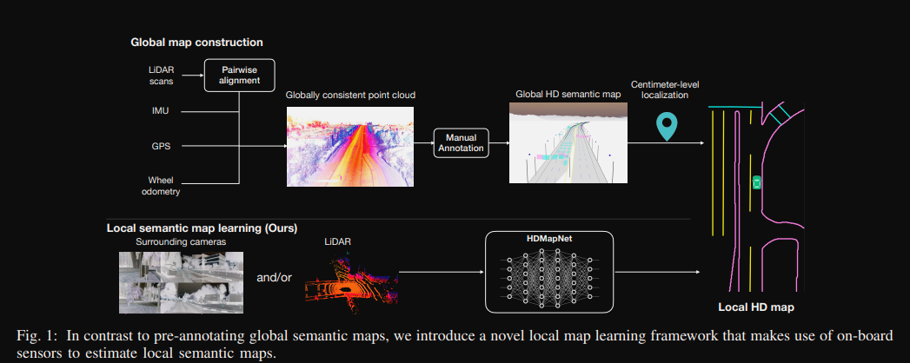

HDMapNet illustration of critical components

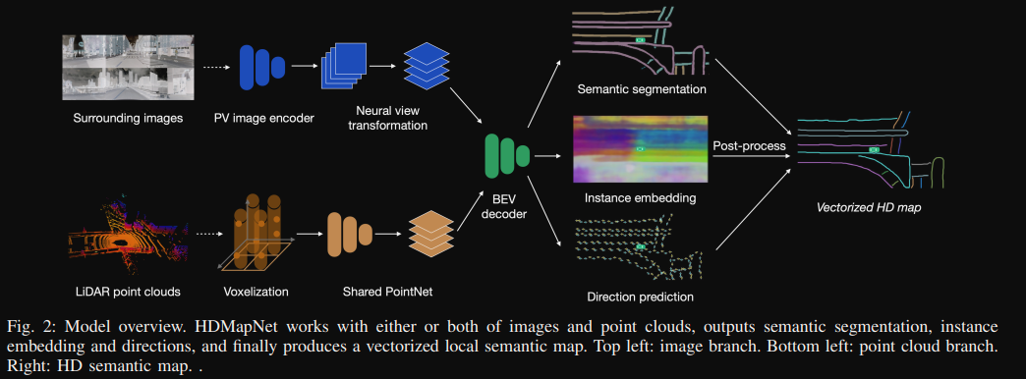

HDMapNet model architecture

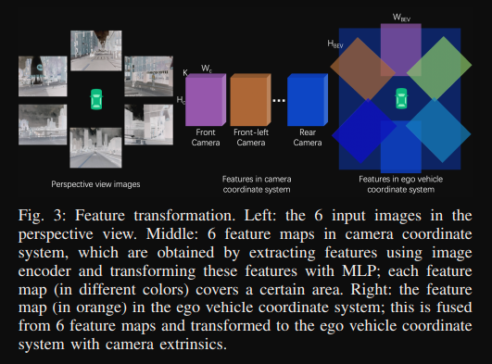

HDMapNet Feature transformation method

Review:

By incorporating surrounding camera and lidar points, HDMapNet achieves a quite good performance on the nuscenes dataset. But it could be a arguable point for the application of HDMapNet to learn for high definition map for autonomous vehicles. If a HD map is learned in real time and referenced in real time, then the HD will not be able to provide any extra information as it supposed to be. For application, it could be served as a gross map generator, then to let human labelors to verify.

### Transfuser: Imitation with Transformer-Based Sensor Fusion for Autonomous Driving

Abstract

How should we integrate representations from complementary sensors for autonomous driving? Geometry-based fusion has shown promise for perception (e.g. object detection, motion forecasting). However, in the context of end-to-end driving, we find that imitation learning based on existing sensor fusion methods underperforms in complex driving scenarios with a high density of dynamic agents. Therefore, we propose TransFuser, a mechanism to integrate image and LiDAR representations using self-attention. Our approach uses transformer modules at multiple resolutions to fuse perspective view and bird’s eye view feature maps. We experimentally validate its efficacy on a challenging new benchmark with long routes and dense traffic, as well as the official leaderboard of the CARLA urban driving simulator. At the time of submission, TransFuser outperforms all prior work on the CARLA leaderboard in terms of driving score by a large margin. Compared to geometry-based fusion, TransFuser reduces the average collisions per kilometer by 48%.

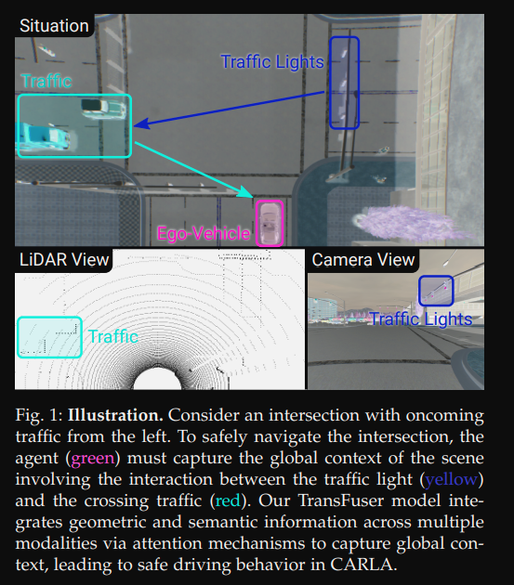

Transfuser Illustration of broadened view of perception

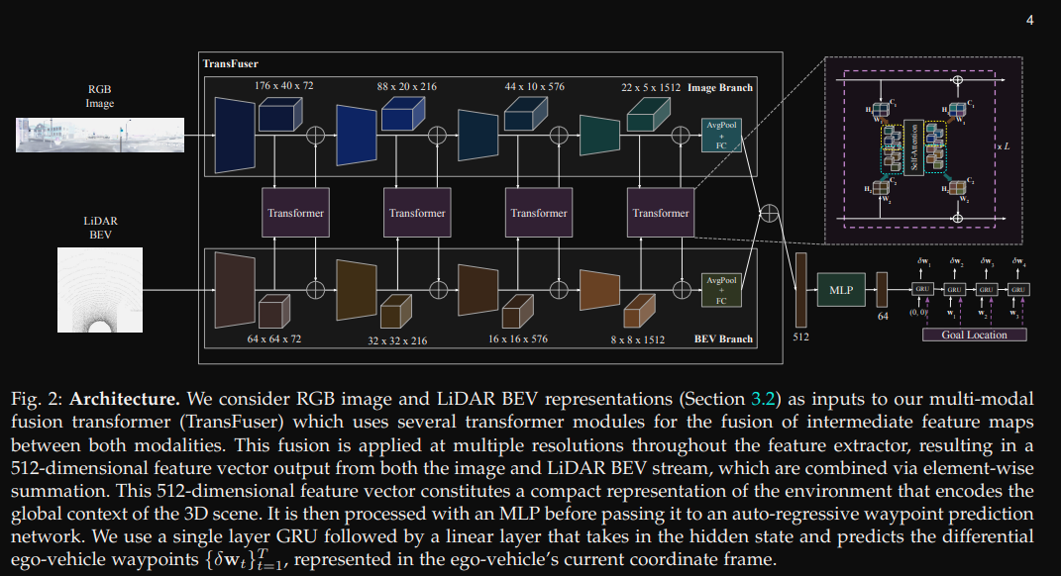

Transfuser model architecture

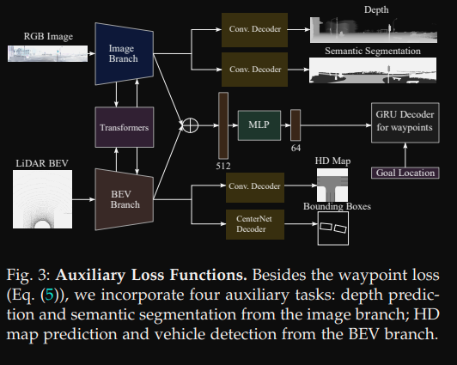

Transfuser Auxiliary loss for multi-task prediction

Review:

Transfuser tries to incorporate all sensory information by a cascaded transformer pipeline, which is a latent BEV representation. The performant result on Carla leaderboard proved the effectiveness of BEV based technique and vision transformer.

### BEVFormer: Learning Bird's-Eye-View Representation from Multi-Camera Images via Spatiotemporal Transformers

Abstract

3D visual perception tasks, including 3D detection and map segmentation based on multi-camera images, are essential for autonomous driving systems. In this work, we present a new framework termed BEVFormer, which learns unified BEV representations with spatiotemporal transformers to support multiple autonomous driving perception tasks. In a nutshell, BEVFormer exploits both spatial and temporal information by interacting with spatial and temporal space through predefined grid-shaped BEV queries. To aggregate spatial information, we design a spatial cross-attention that each BEV query extracts the spatial features from the regions of interest across camera views. For temporal information, we propose a temporal self-attention to recurrently fuse the history BEV information. Our approach achieves the new state-of-the-art 56.9% in terms of NDS metric on the nuScenes test set, which is 9.0 points higher than previous best arts and on par with the performance of LiDAR-based baselines. We further show that BEVFormer remarkably improves the accuracy of velocity estimation and recall of objects under low visibility conditions.

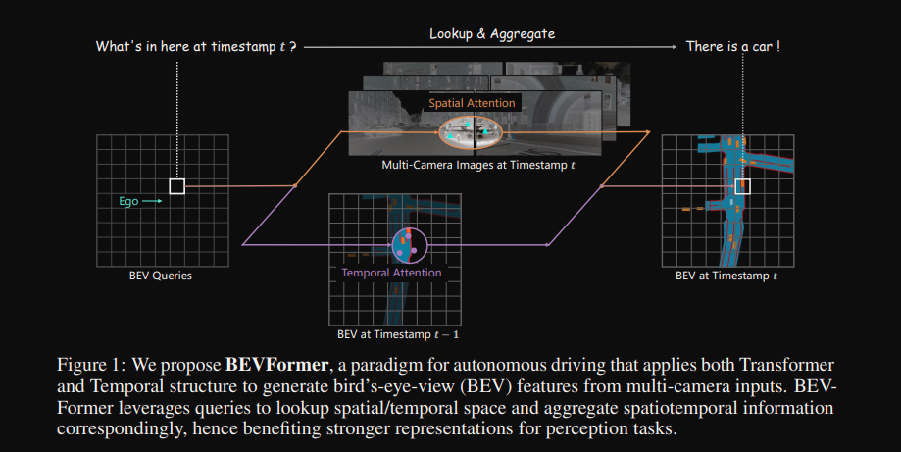

BEVFormer overall pipeline

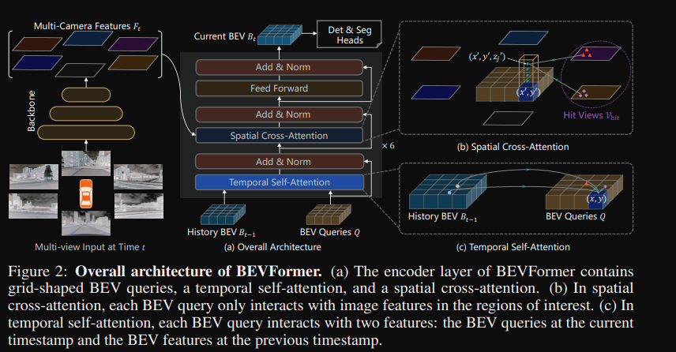

BEVFormer model architecture

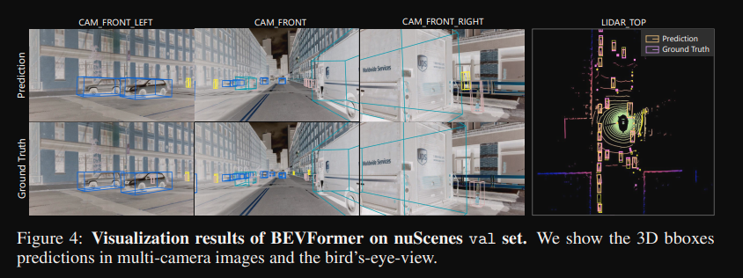

BEVFormer visualization example

Review

BEVFormer first proposed to combine multi-camera input and temporal information to perform perception task under 3D space. By using BEV representation with vision transformer implementation, the BEVFormer model achieves the best performance on nuscenes open challenge. The limitation of BEVFormer or vision transformer based methods are the over demand of computing power, eg. the memory and number of cores in GPU. Another issue with BEVFormer is that it is built upon DETR detector, this anchor free design suffers from the missing tiny objects issue. For further improvement, efficient backbone design and tuning of tiny objects detection would be 2 practical direction.

### BEVDet: High-Performance Multi-Camera 3D Object Detection in Bird-Eye-View

Abstract

Autonomous driving perceives its surroundings for decision making, which is one of the most complex scenarios in visual perception. The success of paradigm innovation in solving the 2D object detection task inspires us to seek an elegant, feasible, and scalable paradigm for fundamentally pushing the performance boundary in this area. To this end, we contribute the BEVDet paradigm in this paper. BEVDet performs 3D object detection in Bird-Eye-View (BEV), where most target values are defined and route planning can be handily performed. We merely reuse existing modules to build its framework but substantially develop its performance by constructing an exclusive data augmentation strategy and upgrading the Non-Maximum Suppression strategy. In the experiment, BEVDet offers an excellent trade-off between accuracy and time-efficiency. As a fast version, BEVDet-Tiny scores 31.2% mAP and 39.2% NDS on the nuScenes val set. It is comparable with FCOS3D, but requires just 11% computational budget of 215.3 GFLOPs and runs 9.2 times faster at 15.6 FPS. Another high-precision version dubbed BEVDet-Base scores 39.3% mAP and 47.2% NDS, significantly exceeding all published results. With a comparable inference speed, it surpasses FCOS3D by a large margin of +9.8% mAP and +10.0% NDS.

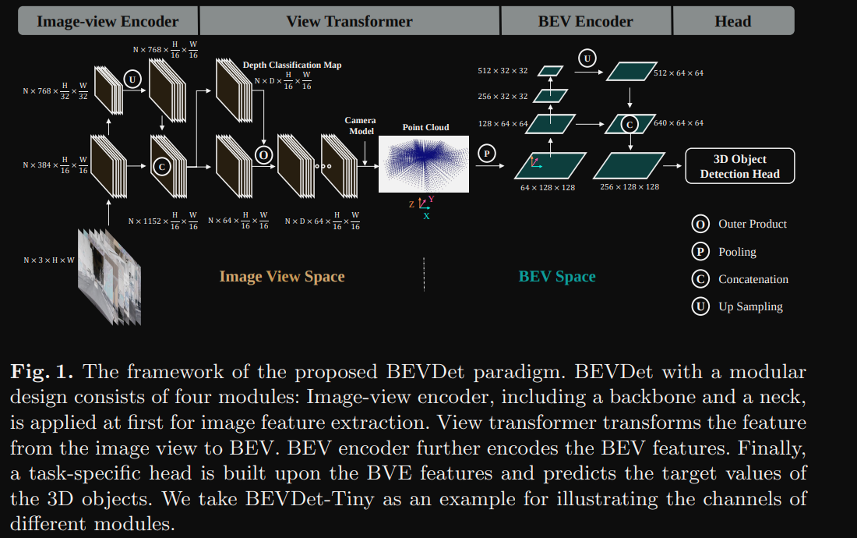

BEVDet model framework

Review:

BEVDet is the extension work of FCOS in BEV space. This work further demonstrated the effectiveness of BEV for fusing sensory input. The novelty is less competitive than other concurrent publications, but the experimental tricks, NMS and data augmentation technique applied are still applicable to model tuning.

### BEVDet4D: Exploit Temporal Cues in Multi-camera 3D Object Detection

Abstract:

Single frame data contains finite information which limits the performance of the existing vision-based multicamera 3D object detection paradigms. For fundamentally pushing the performance boundary in this area, a novel paradigm dubbed BEVDet4D is proposed to lift the scalable BEVDet paradigm from the spatial-only 3D working space into the spatial-temporal 4D working space. We upgrade the naive BEVDet framework with a few modifications just for fusing the feature from the previous frame with the corresponding one in the current frame. In this way, with negligible additional computing budget, we enable BEVDet4D to access the temporal cues by querying and comparing the two candidate features. Beyond this, we simplify the task of velocity prediction by degenerating it into the positional offset prediction in the two adjacent features. As a result, BEVDet4D with robust generalization performance reduces the velocity error by up to -62.9%. This makes the vision-based methods, for the first time, become comparable with those relied on LiDAR or radar in this aspect. On challenge benchmark nuScenes, we report a new record of 54.5% NDS with the high-performance configuration dubbed BEVDet4D-Base. At the same inference speed, this notably surpasses the previous leading method BEVDet-Base by +7.3% NDS.

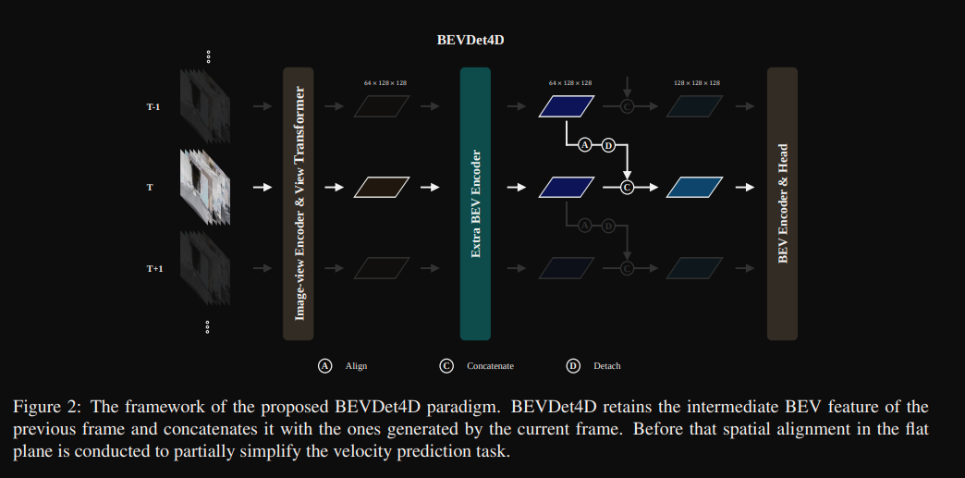

BEVDet4D framework

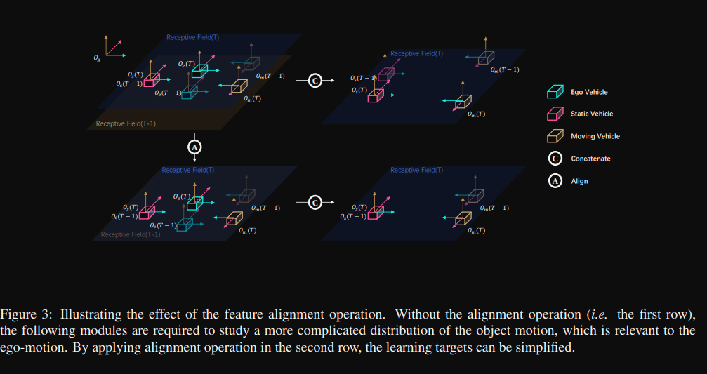

BEVDet4D Illustration of feature alignment.

Review:

BEVDet4D is the follow-up work of BEVDet with additional temporal input. The major error contribution to vision only challenge track on NuScenes is the velocity estimation. With the temporal input added to the model, a notable increment in performance is seen.

### BEVerse: Unified Perception and Prediction in Birds-Eye-View for Vision-Centric Autonomous Driving

Abstract

In this paper, we present BEVerse, a unified framework for 3D perception and prediction based on multicamera systems. Unlike existing studies focusing on the improvement of single-task approaches, BEVerse features in producing spatio-temporal Birds-Eye-View (BEV) representations from multi-camera videos and jointly reasoning about multiple tasks for vision-centric autonomous driving. Specifically, BEVerse first performs shared feature extraction and lifting to generate 4D BEV representations from multi-timestamp and multi-view images. After the egomotion alignment, the spatio-temporal encoder is utilized for further feature extraction in BEV. Finally, multiple task decoders are attached for joint reasoning and prediction. Within the decoders, we propose the grid sampler to generate BEV features with different ranges and granularities for different tasks. Also, we design the method of iterative flow for memory-efficient future prediction. We show that the temporal information improves 3D object detection and semantic map construction, while the multi-task learning can implicitly benefit motion prediction. With extensive experiments on the nuScenes dataset, we show that the multi-task BEVerse outperforms existing single-task methods on 3D object detection, semantic map construction, and motion prediction. Compared with the sequential paradigm, BEVerse also favors in significantly improved efficiency.

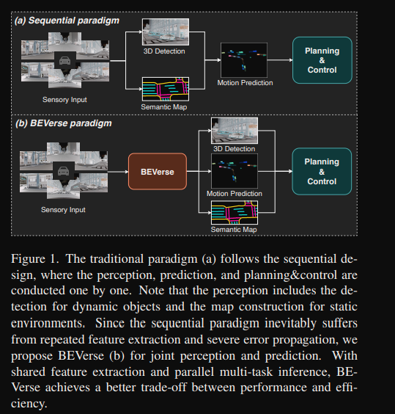

BEVerse Illustration of multi-task model

Review:

BEVerse explores multi-task learning under BEV space for vision-only perception tasks. With multi-head attached to the BEV feature map, object detection, semantic map construction and motion prediction can be done within one model, which greatly reduced the computing complexity of perception module.

### BEVDepth: Acquisition of Reliable Depth for Multi-view 3D Object Detection

Abstract

In this research, we propose a new 3D object detector with a trustworthy depth estimation, dubbed BEVDepth, for camera-based Bird’s-Eye-View (BEV) 3D object detection. By a thorough analysis of recent approaches, we discover that the depth estimation is implicitly learned without camera information, making it the de-facto fake-depth for creating the following pseudo point cloud. BEVDepth gets explicit depth supervision utilizing encoded intrinsic and extrinsic parameters. A depth correction sub-network is further introduced to counteract projecting-induced disturbances in depth ground truth. To reduce the speed bottleneck while projecting features from image-view into BEV using estimated depth, a quick view-transform operation is also proposed. Besides, our BEVDepth can be easily extended with input from multi-frame. Without any bells and whistles, BEVDepth achieves the new state-of-the-art 60.0% NDS on the challenging nuScenes test set while maintaining high efficiency. For the first time, the performance gap between the camera and LiDAR is largely reduced within 10% NDS.

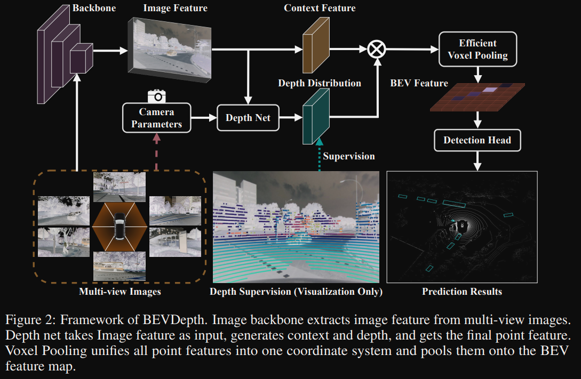

BEVDepth framework

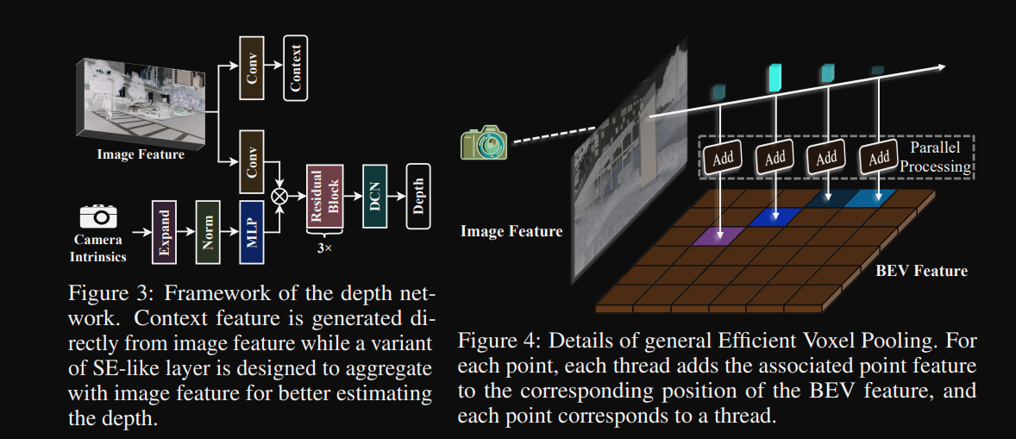

BEVDepth Illustration of depth estimation

Review:

BEVDepth make use of the BEV space to estimate the depth information from multi-surrouding camera. The noval voxel pooling network accelerated the convergence. This work is a waste of expressness of BEV space.

### BEVSegFormer: Bird’s Eye View Semantic Segmentation From Arbitrary Camera Rigs

Abstract

Semantic segmentation in bird’s eye view (BEV) is an important task for autonomous driving. Though this task has attracted a large amount of research efforts, it is still challenging to flexibly cope with arbitrary (single or multiple) camera sensors equipped on the autonomous vehicle. In this paper, we present BEVSegFormer, an effective transformerbased method for BEV semantic segmentation from arbitrary camera rigs. Specifically, our method first encodes image features from arbitrary cameras with a shared backbone. These image features are then enhanced by a deformable transformerbased encoder. Moreover, we introduce a BEV transformer decoder module to parse BEV semantic segmentation results. An efficient multi-camera deformable attention unit is designed to carry out the BEV-to-image view transformation. Finally, the queries are reshaped according the layout of grids in the BEV, and upsampled to produce the semantic segmentation result in a supervised manner. We evaluate the proposed algorithm on the public nuScenes dataset and a self-collected dataset. Experimental results show that our method achieves promising performance on BEV semantic segmentation from arbitrary camera rigs. We also demonstrate the effectiveness of each component via ablation study.

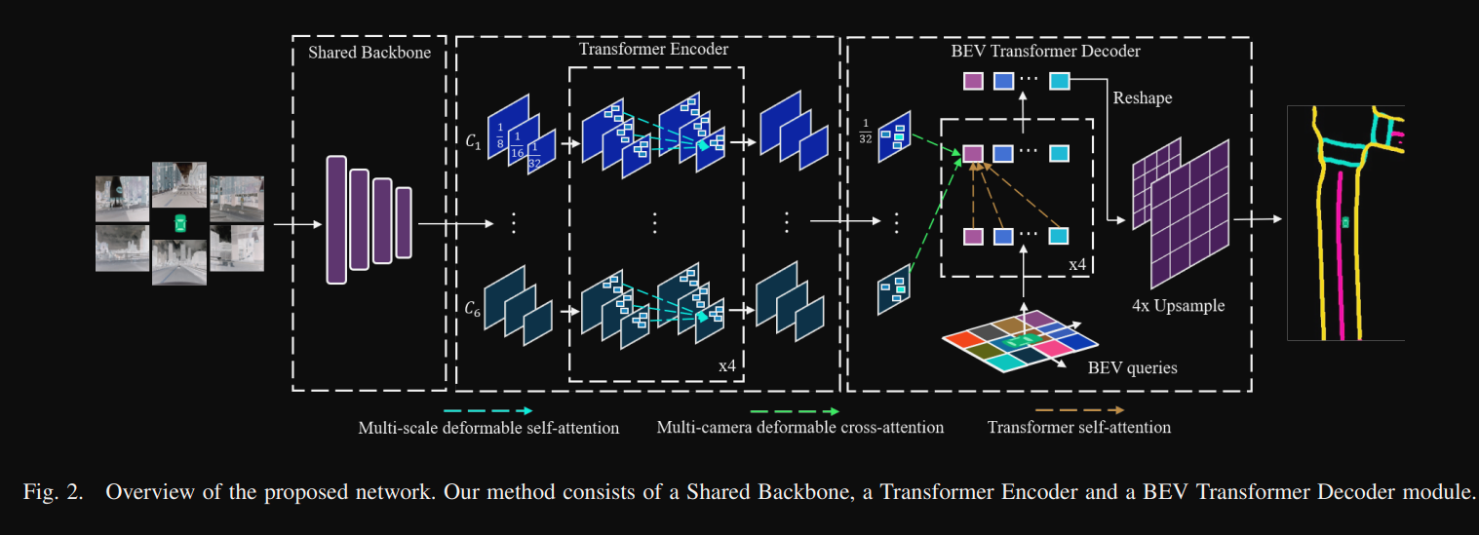

BEVSegFormer architecture

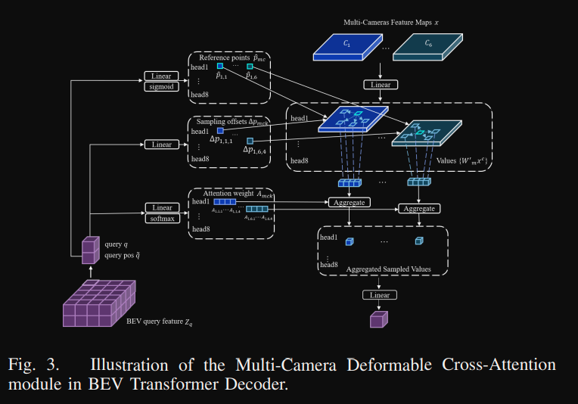

BEVFormer Deformable-Attention Layer Design

Review:

BEVSegFormer proposed to generate segmentation mask without relying on intrinsic and extrinsic sensor calibration. With the use of transformer, it hides the calibration process with latent variables which much simplified the segmentation generation process. This work could be a good referenc to the further design of calibration free model.

### M2BEV: Multi-Camera Joint 3D Detection and Segmentation with Unified Bird’s-Eye View Representation

Abstract:

In this paper, we propose M2BEV, a unified framework that jointly performs 3D object detection and map segmentation in the Bird’s Eye View (BEV) space with multi-camera image inputs. Unlike the majority of previous works which separately process detection and segmentation, M2BEV infers both tasks with a unified model and improves efficiency. M2BEV efficiently transforms multi-view 2D image features into the 3D BEV feature in ego-car coordinates. Such BEV representation is important as it enables different tasks to share a single encoder. Our framework further contains four important designs that benefit both accuracy and efficiency: (1) An efficient BEV encoder design that reduces the spatial dimension of a voxel feature map. (2) A dynamic box assignment strategy that uses learning-to-match to assign ground-truth 3D boxes with anchors. (3) A BEV centerness re-weighting that reinforces with larger weights for more distant predictions, and (4) Large-scale 2D detection pre-training and auxiliary supervision. We show that these designs significantly benefit the ill-posed camera-based 3D perception tasks where depth information is missing. M2BEV is memory efficient, allowing significantly higher resolution images as input, with faster inference speed. Experiments on nuScenes show that M2BEV achieves state-of-the-art results in both 3D object detection and BEV segmentation, with the best single model achieving 42.5 mAP and 57.0 mIoU in these two tasks, respectively.

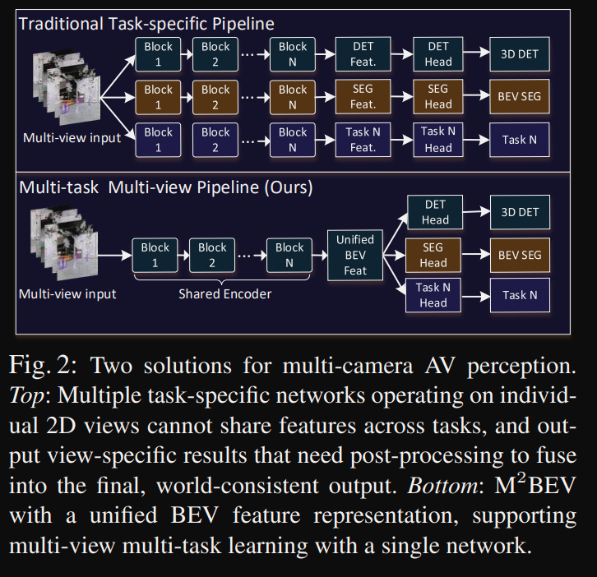

M2BEV is a multi-task framework

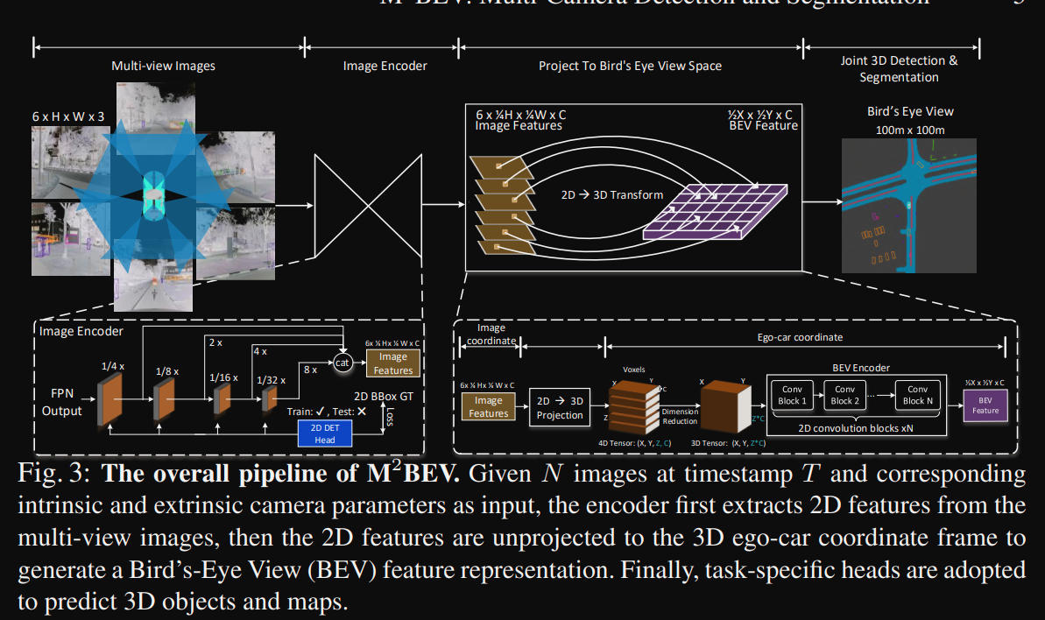

M2BEV overall architecture

Review  
M2BEV first proposed the multi-task learning under BEV space. To learn detector and segmentor together on top of the BEV encoder. The design of spatial-to-channel module may helps to reduce the heavy computation cost. Many tricks have been tried to improve the performance of detectors including dynamic bbox assignment, centerness score of bbox to focus on small objects and 2D detector pretraining. All of these tricks can be migrated to our current experiments.

### SwinTransformer: Hierarchical Vision Transformer using Shifted Windows

Abstract:

This paper presents a new vision Transformer, called Swin Transformer, that capably serves as a general-purpose backbone for computer vision. Challenges in adapting Transformer from language to vision arise from differences between the two domains, such as large variations in the scale of visual entities and the high resolution of pixels in images compared to words in text. To address these differences, we propose a hierarchical Transformer whose representation is computed with Shifted windows. The shifted windowing scheme brings greater efficiency by limiting self-attention computation to non-overlapping local windows while also allowing for cross-window connection. This hierarchical architecture has the flexibility to model at various scales and has linear computational complexity with respect to image size. These qualities of Swin Transformer make it compatible with a broad range of vision tasks, including image classification (87.3 top-1 accuracy on ImageNet-1K) and dense prediction tasks such as object detection (58.7 box AP and 51.1 mask AP on COCO testdev) and semantic segmentation (53.5 mIoU on ADE20K val). Its performance surpasses the previous state-of-theart by a large margin of +2.7 box AP and +2.6 mask AP on COCO, and +3.2 mIoU on ADE20K, demonstrating the potential of Transformer-based models as vision backbones. The hierarchical design and the shifted window approach also prove beneficial for all-MLP architectures.

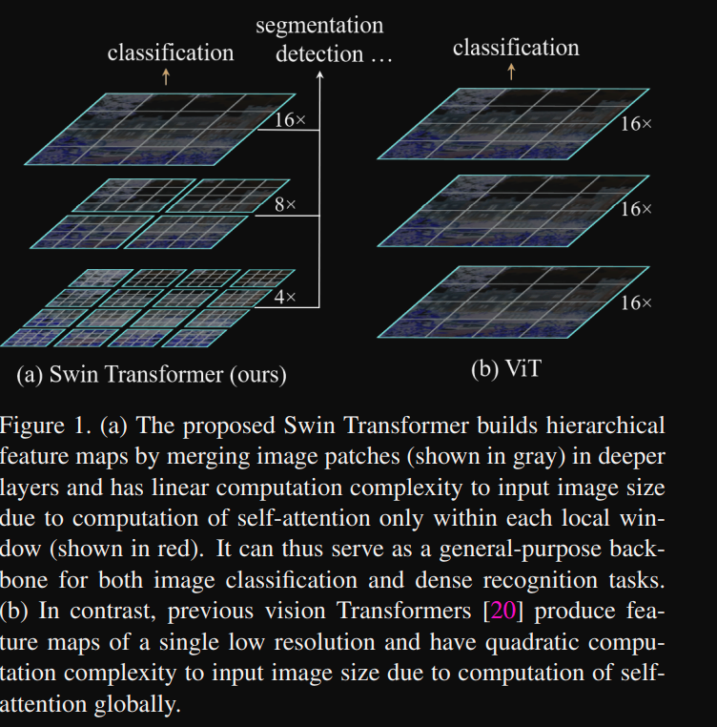

SwinTransformer: Illustration of SwinTransformer Architecture.

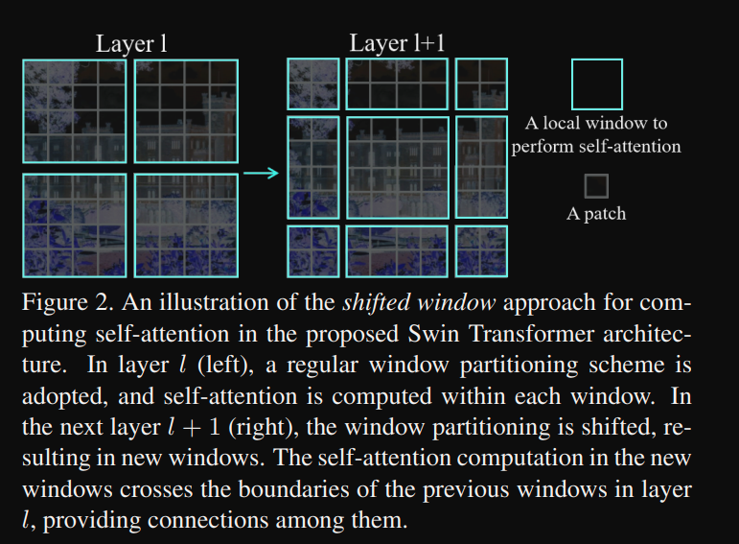

SwinTransformer: The design of shifted window

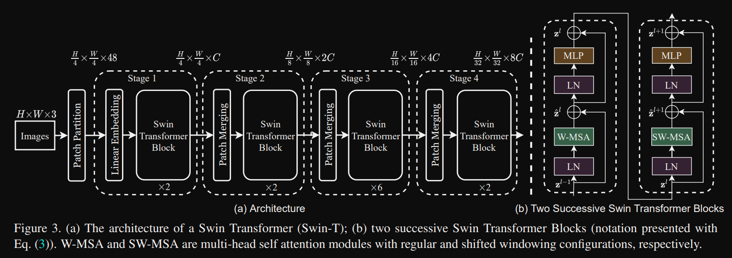

SwinTransformer: Model Architecture

Review:

SwinTransformer brings in the prior knowledge of image, with the hierarchical arrangement of attention module, the calculation process is much similar to the convolutions of pixe/feature values. SwinTransformer is a more effective backbone model with transformer architecture. But not necessarily to be the best backbone model. This is a improved version of ViT.

### SimMIM: a Simple Framework for Masked Image Modeling

Abstract:

This paper presents SimMIM, a simple framework for masked image modeling. We have simplified recently proposed relevant approaches, without the need for special designs, such as block-wise masking and tokenization via discrete VAE or clustering. To investigate what makes a masked image modeling task learn good representations, we systematically study the major components in our framework, and find that the simple designs of each component have revealed very strong representation learning performance: 1) random masking of the input image with a moderately large masked patch size (e.g., 32) makes a powerful pre-text task; 2) predicting RGB values of raw pixels by direct regression performs no worse than the patch classification approaches with complex designs; 3) the prediction head can be as light as a linear layer, with no worse performance than heavier ones. Using ViT-B, our approach achieves 83.8% top-1 fine-tuning accuracy on ImageNet-1K by pre-training also on this dataset, surpassing previous best approach by +0.6%. When applied to a larger model with about 650 million parameters, SwinV2- H, it achieves 87.1% top-1 accuracy on ImageNet-1K using only ImageNet-1K data. We also leverage this approach to address the data-hungry issue faced by large-scale model training, that a 3B model (SwinV2-G) is successfully trained to achieve state-of-the-art accuracy on four representative vision benchmarks using 40× less labelled data than that in previous practice (JFT-3B).

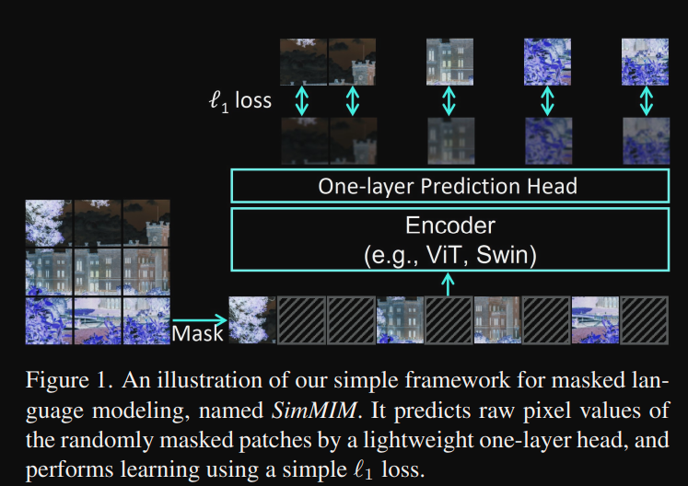

SimMIM framework

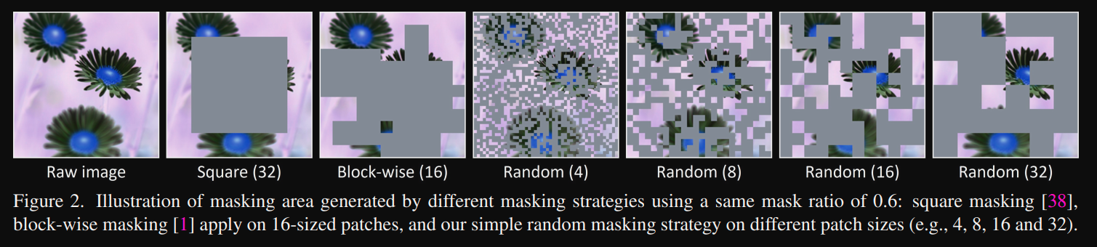

SimMIM illustration of mask generation method

Review:

Self-supervised learning is believed to be the next generation of backbone models to utilize large scale unlabelled data. This paper presents a simple yet effective self-supervised learning framework, SimMIM, to leverage masked image modeling for representation learning. This framework is made as simple as possible: 1) a random masking strategy with a moderately large masked patch size; 2) predicting raw pixels of RGB values by direct regression task; 3) the prediction head can be as light as a linear layer.

### MAE: Masked Autoencoders Are Scalable Vision Learners

Abstract:

This paper shows that masked autoencoders (MAE) are scalable self-supervised learners for computer vision. Our MAE approach is simple: we mask random patches of the input image and reconstruct the missing pixels. It is based on two core designs. First, we develop an asymmetric encoder-decoder architecture, with an encoder that operates only on the visible subset of patches (without mask tokens), along with a lightweight decoder that reconstructs the original image from the latent representation and mask tokens. Second, we find that masking a high proportion of the input image, e.g., 75%, yields a nontrivial and meaningful self-supervisory task. Coupling these two designs enables us to train large models efficiently and effectively: we accelerate training (by 3× or more) and improve accuracy. Our scalable approach allows for learning high-capacity models that generalize well: e.g., a vanilla ViT-Huge model achieves the best accuracy (87.8%) among methods that use only ImageNet-1K data. Transfer performance in downstream tasks outperforms supervised pretraining and shows promising scaling behavior.

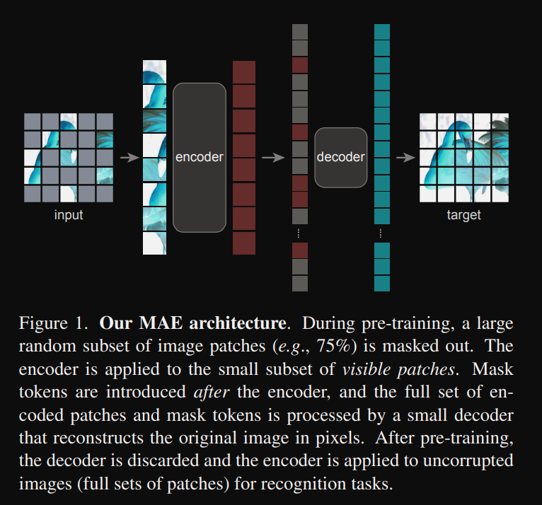

MAE model architecture

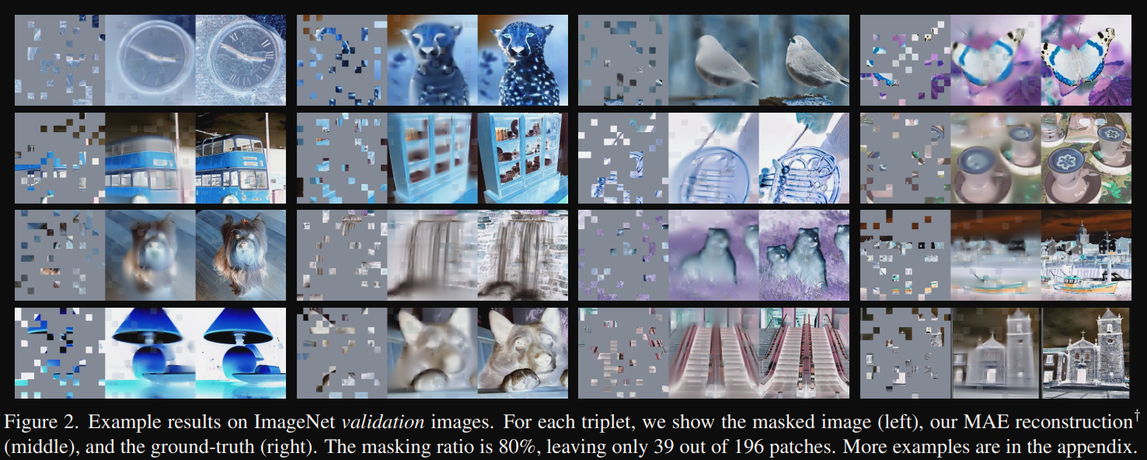

MAE examples

Review:

MAE is another simple yet effective framework for self-supervised learning. Simple algorithms that scale well are the core of deep learning. In NLP, simple self-supervised learning methods enable benefits from exponentially scaling models. In computer vision, practical pre-training paradigms are dominantly supervised despite progress in self-supervised learning. Autoencoder—a simple self-supervised method similar to techniques in NLP—provides scalable benefits. Selfsupervised learning in vision may now be embarking on a similar trajectory as in NLP. Images and languages are signals of a different nature and this difference must be addressed carefully. Images are merely recorded light without a semantic decomposition into the visual analogue of words. Instead of attempting to remove objects, we remove random patches that most likely do not form a semantic segment. MAE reconstructs pixels, which are not semantic entities. MAE infers complex, holistic reconstructions, suggesting it has learned numerous visual concepts.

VisionGNN: An Image is Worth Graph of Nodes

Abstract:

Network architecture plays a key role in the deep learning-based computer vision system. The widely-used convolutional neural network and transformer treat the image as a grid or sequence structure, which is not flexible to capture irregular and complex objects. In this paper, we propose to represent the image as a graph structure and introduce a new Vision GNN (ViG) architecture to extract graphlevel feature for visual tasks. We first split the image to a number of patches which are viewed as nodes, and construct a graph by connecting the nearest neighbors. Based on the graph representation of images, we build our ViG model to transform and exchange information among all the nodes. ViG consists of two basic modules: Grapher module with graph convolution for aggregating and updating graph information, and FFN module with two linear layers for node feature transformation. Both isotropic and pyramid architectures of ViG are built with different model sizes. Extensive experiments on image recognition and object detection tasks demonstrate the superiority of our ViG architecture. We hope this pioneering study of GNN on general visual tasks will provide useful inspiration and experience for future research.

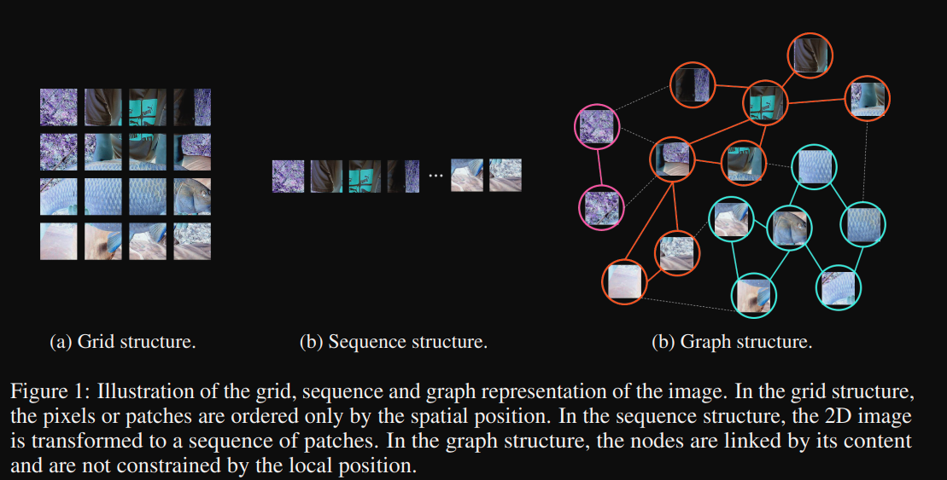

ViG: Graph representation of image

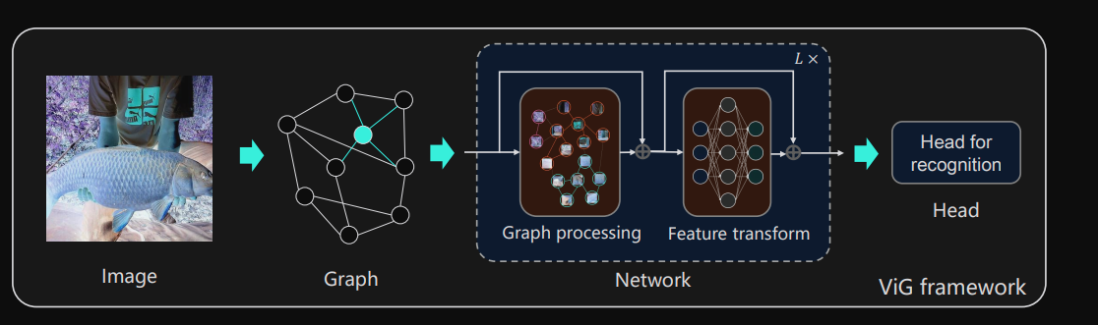

ViG Framework

Review:

GNN is a generalized form of neural networks, while convolutional neural networks are considered the special form of GNN. After the invention of ViT, it is valuable to investigate the effectiveness of the root form of connectionism on vision tasks.

### Mlp-mixer: An all-mlp architecture for vision

Abstract

Convolutional Neural Networks (CNNs) are the go-to model for computer vision. Recently, attention-based networks, such as the Vision Transformer, have also become popular. In this paper we show that while convolutions and attention are both sufficient for good performance, neither of them are necessary. We present MLP-Mixer, an architecture based exclusively on multi-layer perceptrons (MLPs). MLP-Mixer contains two types of layers: one with MLPs applied independently to image patches (i.e. “mixing” the per-location features), and one with MLPs applied across patches (i.e. “mixing” spatial information). When trained on large datasets, or with modern regularization schemes, MLP-Mixer attains competitive scores on image classification benchmarks, with pre-training and inference cost comparable to state-of-the-art models. We hope that these results spark further research beyond the realms of well established CNNs and Transformers.

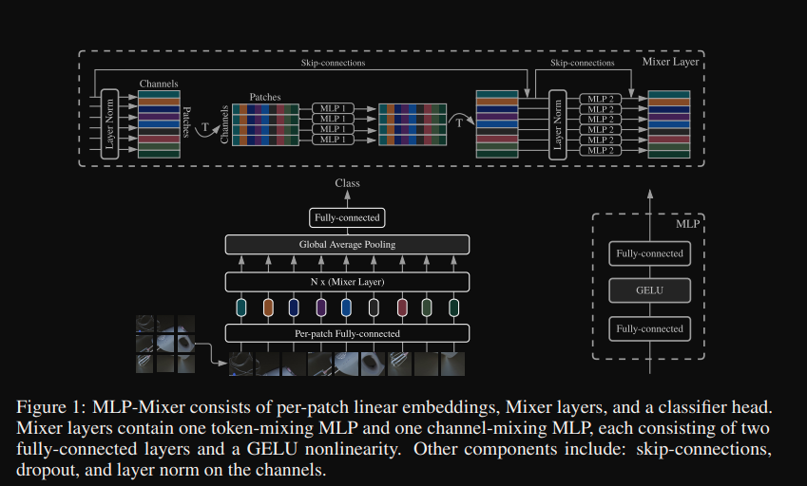

MLP-Mixer Architecture

Review:

Yet another paper applying MLP on vision problems.

### Resmlp: Feedforward networks for image classification with data-efficient training.

Abstract:

We present ResMLP, an architecture built entirely upon multi-layer perceptrons for image classification. It is a simple residual network that alternates (i) a linear layer in which image patches interact, independently and identically across channels, and (ii) a two-layer feed-forward network in which channels interact independently per patch. When trained with a modern training strategy using heavy data-augmentation and optionally distillation, it attains surprisingly good accuracy/complexity tradeoffs on ImageNet. We also train ResMLP models in a self-supervised setup, to further remove priors from employing a labelled dataset. Finally, by adapting our model to machine translation we achieve surprisingly good results. We share pre-trained models and our code based on the Timm library

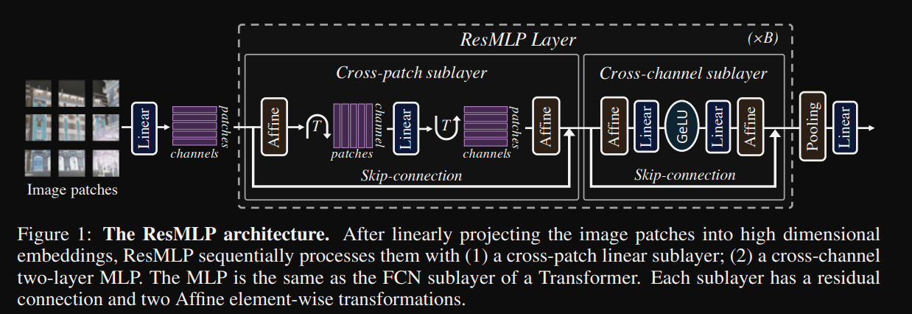

ResMLP architecture

Review:

Pure MLP architecture for vision problems.

### ConvMixer: Patches are all you need

Abstract

Although convolutional networks have been the dominant architecture for vision tasks for many years, recent experiments have shown that Transformer-based models, most notably the Vision Transformer (ViT), may exceed their performance in some settings. However, due to the quadratic runtime of the self-attention layers in Transformers, ViTs require the use of patch embeddings, which group together small regions of the image into single input features, in order to be applied to larger image sizes. This raises a question: Is the performance of ViTs due to the inherently-more-powerful Transformer architecture, or is it at least partly due to using patches as the input representation? In this paper, we present some evidence for the latter: specifically, we propose the ConvMixer, an extremely simple model that is similar in spirit to the ViT and the even-more-basic MLP-Mixer in that it operates directly on patches as input, separates the mixing of spatial and channel dimensions, and maintains equal size and resolution throughout the network. In contrast, however, the ConvMixer uses only standard convolutions to achieve the mixing steps. Despite its simplicity, we show that the ConvMixer outperforms the ViT, MLP-Mixer, and some of their variants for similar parameter counts and data set sizes, in addition to outperforming classical vision models such as the ResNet.

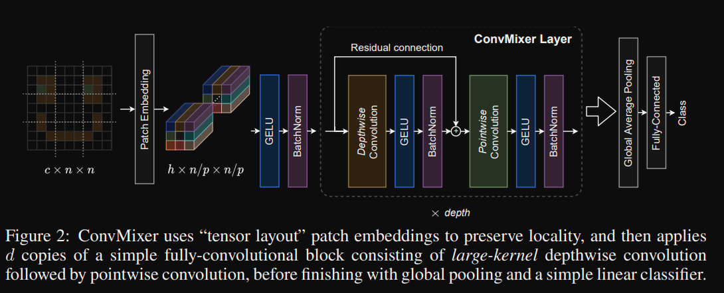

ConvMixer architecture

Review:

The success of the ViT model has spurred tremendous interests in the design of variants of Transformer architecture. ConvMixer explorers by possibly using standard convolutional layers to achieve the mixing step of spatial and channel dimensions. Not a very serious work.

### DN-DETR: Accelerate DETR Training by Introducing Query DeNoising

Abstract

We present in this paper a novel denoising training method to speedup DETR (DEtection TRansformer) training and offer a deepened understanding of the slow convergence issue of DETR-like methods. We show that the slow convergence results from the instability of bipartite graph matching which causes inconsistent optimization goals in early training stages. To address this issue, except for the Hungarian loss, our method additionally feeds ground-truth bounding boxes with noises into Transformer decoder and trains the model to reconstruct the original boxes, which effectively reduces the bipartite graph matching difficulty and leads to a faster convergence. Our method is universal and can be easily plugged into any DETR-like methods by adding dozens of lines of code to achieve a remarkable improvement. As a result, our DN-DETR results in a remarkable improvement (+1.9AP) under the same setting and achieves the best result (AP 43.4 and 48.6 with 12 and 50 epochs of training respectively) among DETR-like methods with ResNet-50 backbone. Compared with the baseline under the same setting, DN-DETR achieves comparable performance with 50% training epochs.

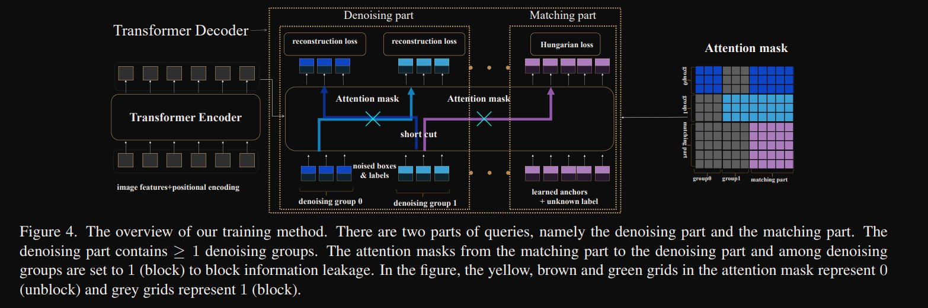

DN-DETR architecture

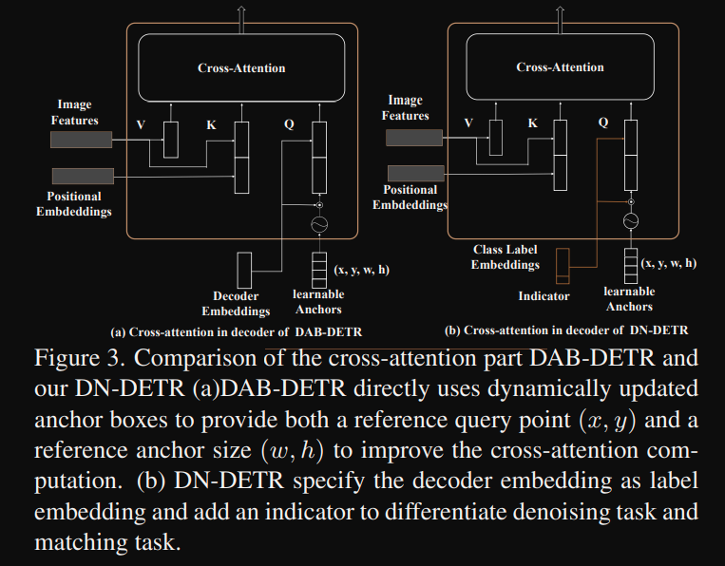

DN-DETR DAB-DETR comparision

Review:

DN-DETR thoroughly analysed the slow convergence issue from DETR training and identified one of the cause is insatiable bi-partite matching algorithm suring training, and thereafter proposed a denoised-training method to accelerate the training process. This denoised training method is a universal module that can be easily extended to other tasks. Since BEVFormer is built based on DETR algorithm, this method could be a way to also accelerate the training process of BEVFormer.

### SAM-DETR: Accelerating DETR Convergence via Semantic-Aligned Matching

Abstract

The recently developed DEtection TRansformer (DETR) establishes a new object detection paradigm by eliminating a series of hand-crafted components. However, DETR suffers from extremely slow convergence, which increases the training cost significantly. We observe that the slow convergence is largely attributed to the complication in matching object queries with target features in different feature embedding spaces. This paper presents SAM-DETR, a Semantic-Aligned-Matching DETR that greatly accelerates DETR’s convergence without sacrificing its accuracy. SAM-DETR addresses the convergence issue from two perspectives. First, it projects object queries into the same embedding space as encoded image features, where the matching can be accomplished efficiently with aligned semantics. Second, it explicitly searches salient points with the most discriminative features for semantic-aligned matching, which further speeds up the convergence and boosts detection accuracy as well. Being like a plug and play, SAMDETR complements existing convergence solutions well yet only introduces slight computational overhead. Extensive experiments show that the proposed SAM-DETR achieves superior convergence as well as competitive detection accuracy.

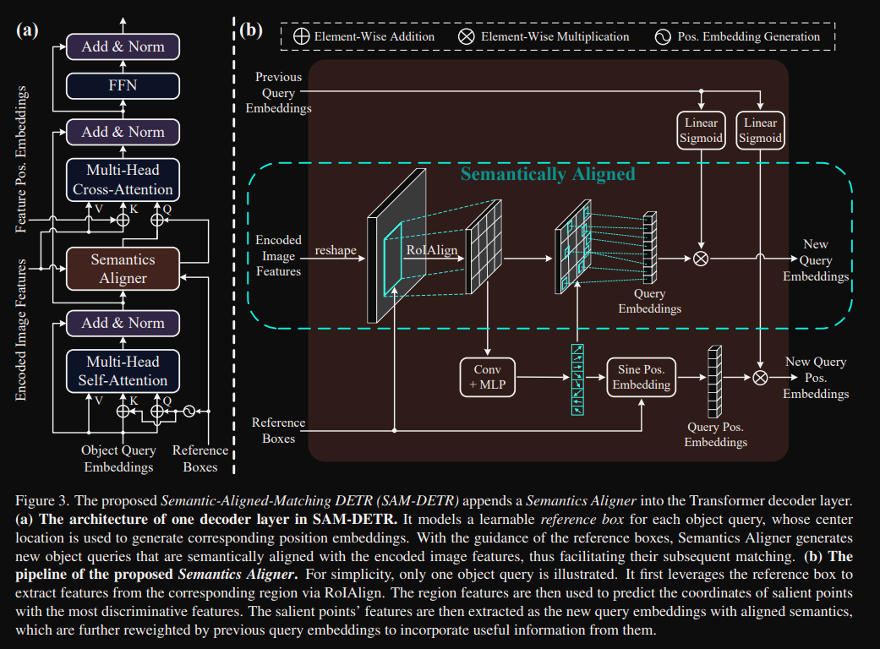

SAM-DETR architecture

Review:

SAM-DETR is yet another paper that tries to analyze and accelerate the convergence process of DETR paper. The insight from SAM-DETR is that the features from objects of the same categories are not aligned well, and salient features are not detected efficiently.

### FreeAnchor: Learning to Match Anchors for Visual Object Detection

Abstract:

Modern CNN-based object detectors assign anchors for ground-truth objects under the restriction of object-anchor Intersection-over-Unit (IoU). In this study, we propose a learning-to-match approach to break IoU restriction, allowing objects to match anchors in a flexible manner. Our approach, referred to as FreeAnchor, updates hand-crafted anchor assignment to “free" anchor matching by formulating detector training as a maximum likelihood estimation (MLE) procedure. FreeAnchor targets at learning features which best explain a class of objects in terms of both classification and localization. FreeAnchor is implemented by optimizing detection customized likelihood and can be fused with CNN-based detectors in a plug-and-play manner. Experiments on COCO demonstrate that FreeAnchor consistently outperforms the counterparts with significant margins

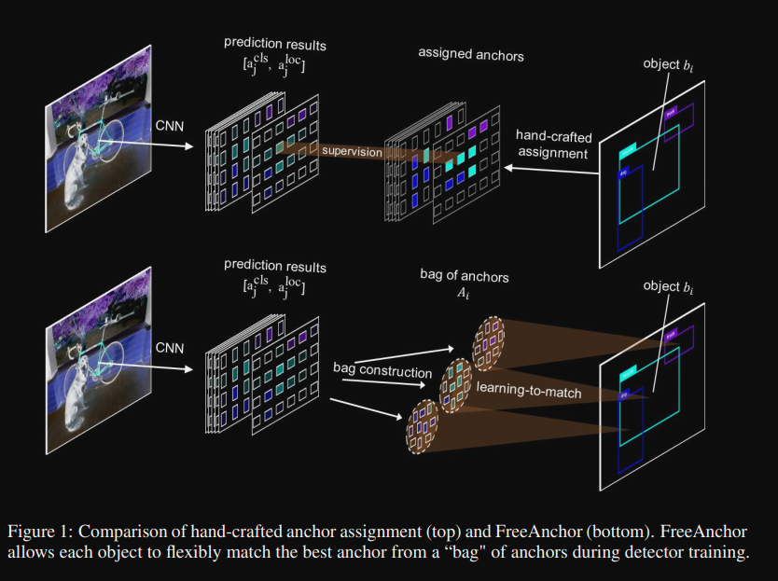

Illustration of FreeAnchor

Review:

First proposed to use learn to assign bbox. By convert the hand-crafted anchor design to a learning problem, anchors learned will be much more fitted to the dataset therefore improve the detection performance. This can be extended to the 3D space.

### PointPillar: Fast Encoders for Object Detection from Point Clouds

Abstract:

Object detection in point clouds is an important aspect of many robotics applications such as autonomous driving. In this paper, we consider the problem of encoding a point cloud into a format appropriate for a downstream detection pipeline. Recent literature suggests two types of encoders; fixed encoders tend to be fast but sacrifice accuracy, while encoders that are learned from data are more accurate, but slower. In this work, we propose PointPillars, a novel encoder which utilizes PointNets to learn a representation of point clouds organized in vertical columns (pillars). While the encoded features can be used with any standard 2D convolutional detection architecture, we further propose a lean downstream network. Extensive experimentation shows that PointPillars outperforms previous encoders with respect to both speed and accuracy by a large margin. Despite only using lidar, our full detection pipeline significantly outperforms the state of the art, even among fusion methods, with respect to both the 3D and bird’s eye view KITTI benchmarks. This detection performance is achieved while running at 62 Hz: a 2 - 4 fold runtime improvement. A faster version of our method matches the state of the art at 105 Hz. These benchmarks suggest that PointPillars is an appropriate encoding for object detection in point clouds.

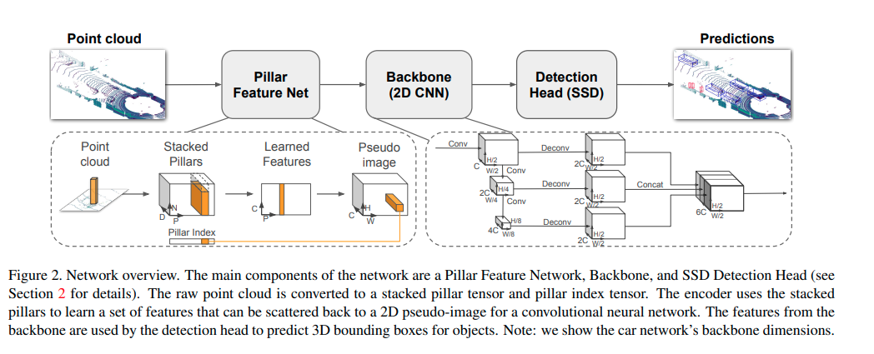

Architecture of PointPillar

Review:

FointPillars is the first paper proposed to project 2D information from surroundings to be in the form of a pillar, this boosts the performance of 3D object detection hence served as the base of modern 3D object detection.

### PETR: Position Embedding Transformation for Multi-View 3D Object Detection

Abstract

In this paper, we develop position embedding transformation (PETR) for multi-view 3D object detection. PETR encodes the position information of 3D coordinates into image features, producing the 3D position-aware features. Object query can perceive the 3D positionaware features and perform end-to-end object detection. PETR achieves state-of-the-art performance (50.4% NDS and 44.1% mAP) on standard nuScenes dataset and ranks 1st place on the benchmark. It can serve as a simple yet strong baseline for future research.

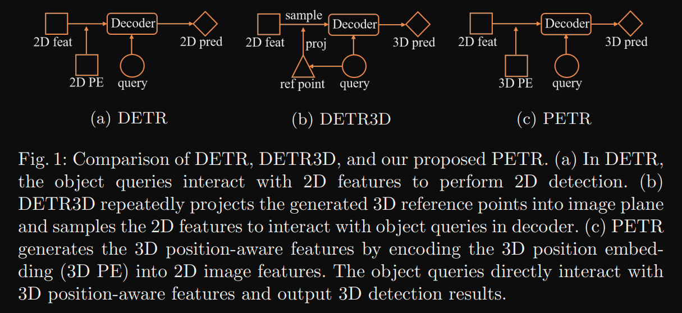

PETR:Comparison of FlowChart

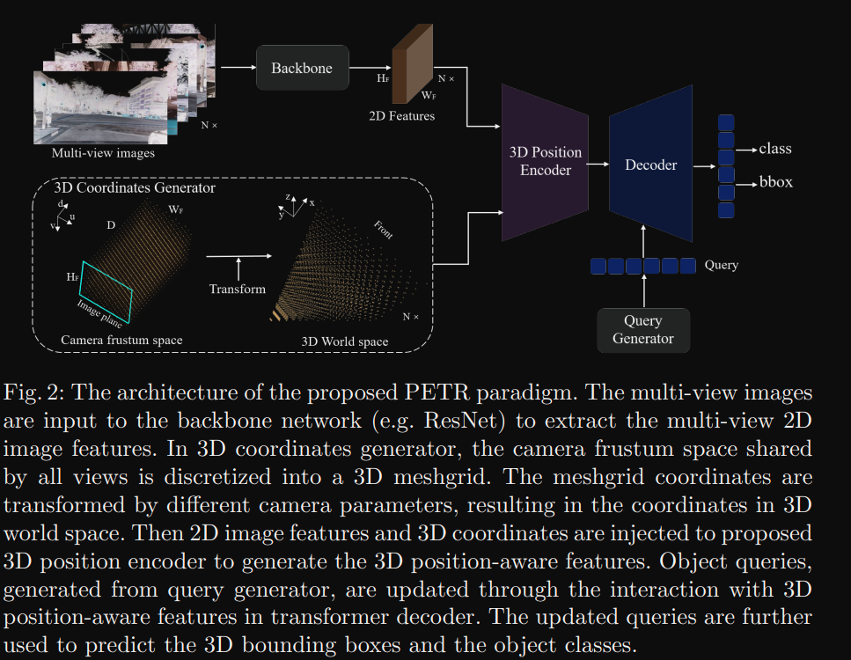

PETR Architecture

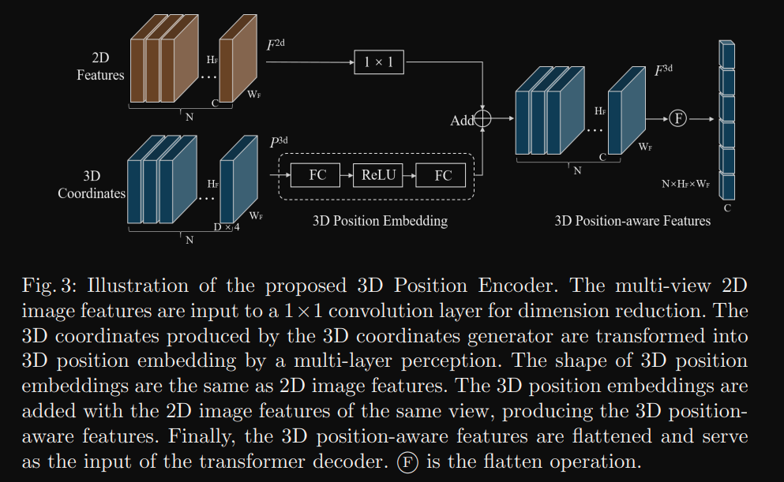

PETR Illustration of 3D position Encoder

Review:

PETR proposed to associate 3D position of objects with feature space from multi-view input. Simply adding a additional input channel will boost performance by a large margin. This proves that more information will always work.

### BEVFusion: Multi-Task Multi-Sensor Fusion with Unified Bird's-Eye View Representation

Abstract  
Multi-sensor fusion is essential for an accurate and reliable autonomous driving system. Recent approaches are based on point-level fusion: augmenting the LiDAR point cloud with camera features. However, the camera-to-LiDAR projection throws away the semantic density of camera features, hindering the effectiveness of such methods, especially for semantic-oriented tasks (such as 3D scene segmentation). In this paper, we break this deeply-rooted convention with BEVFusion, an efficient and generic multi-task multi-sensor fusion framework. It unifies multimodal features in the shared bird’s-eye view (BEV) representation space, which nicely preserves both geometric and semantic information. To achieve this, we diagnose and lift key efficiency bottlenecks in the view transformation with optimized BEV pooling, reducing latency by more than 40×. BEVFusion is fundamentally task-agnostic and seamlessly supports different 3D perception tasks with almost no architectural changes. It establishes the new state of the art on nuScenes, achieving 1.3% higher mAP and NDS on 3D object detection and 13.6% higher mIoU on BEV map segmentation, with 1.9× lower computation cost. Code to reproduce our results is available at <https://github.com/mit-han-lab/bevfusion>.

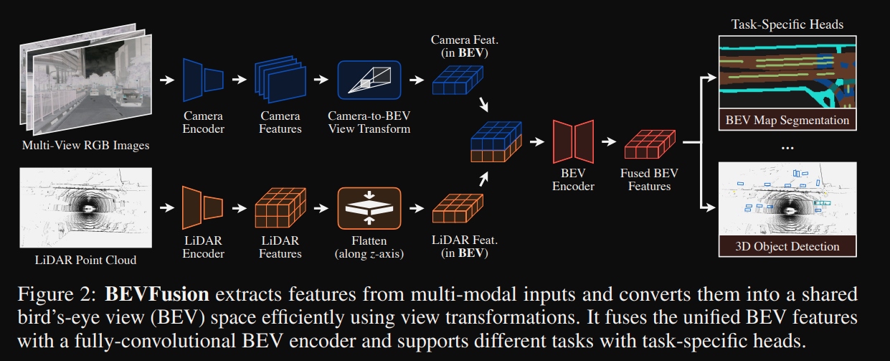

BEVFusion Architecture

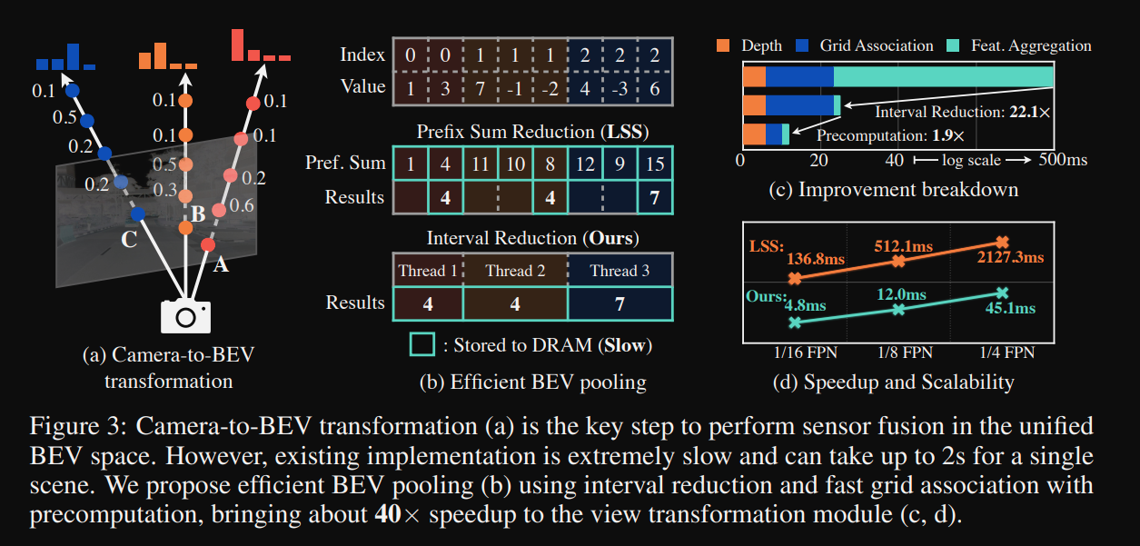

BEVfusion sensor fusion design

Review:

BEVFusion is the 1st ranking algorithm on nuScenes open-set detection leaderboard. It ensembled many design choices from previous work to form a unified many-task framework. It also faced the performance degradation issue from learning detection and segmentation together. BEVFusion is a multi-sensor input framework with both Lidar and camera input, this work could serve as the reference for 3D camera only detection task and as the baseline for future sensor fusion tasks.

### TransFusion: Robust LiDAR-Camera Fusion for 3D Object Detection with Transformers

Abstract:

LiDAR and camera are two important sensors for 3D object detection in autonomous driving. Despite the increasing popularity of sensor fusion in this field, the robustness against inferior image conditions, e.g., bad illumination and sensor misalignment, is under-explored. Existing fusion methods are easily affected by such conditions, mainly due to a hard association of LiDAR points and image pixels, established by calibration matrices. We propose TransFusion, a robust solution to LiDARcamera fusion with a soft-association mechanism to handle inferior image conditions. Specifically, our TransFusion consists of convolutional backbones and a detection head based on a transformer decoder. The first layer of the decoder predicts initial bounding boxes from a LiDAR point cloud using a sparse set of object queries, and its second decoder layer adaptively fuses the object queries with useful image features, leveraging both spatial and contextual relationships. The attention mechanism of the transformer enables our model to adaptively determine where and what information should be taken from the image, leading to a robust and effective fusion strategy. We additionally design an image-guided query initialization strategy to deal with objects that are difficult to detect in point clouds. TransFusion achieves state-of-the-art performance on large-scale datasets. We provide extensive experiments to demonstrate its robustness against degenerated image quality and calibration errors. We also extend the proposed method to the 3D tracking task and achieve the 1st place in the leaderboard of nuScenes tracking, showing its effectiveness and generalization capability.

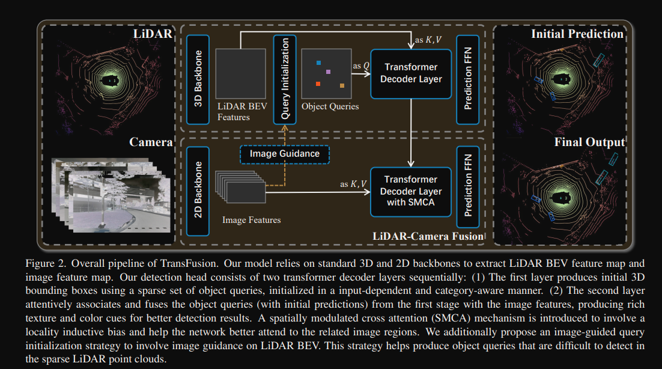

Transfusion pipeline

Review:

TransFusion aims at the robustness of lidar-camera fusion function. Sensors, either camera or Lidar, may dysfunction at certain circumstances, which will add noise to input of perception module, causing degraded performance. It’s good initiative to investigate the root cause, but this work didn’t try to solve in a straightforward way to handle the noisy input from sensors. The overall architecture may be a good reference for design of sensor fusion module.

### Beyond Fixation: Dynamic Window Visual Transformer

Abstract:

Recently, a surge of interest in visual transformers is to reduce the computational cost by limiting the calculation of self-attention to a local window. Most current work uses a fixed single-scale window for modeling by default, ignoring the impact of window size on model performance. However, this may limit the modeling potential of these windowbased models for multi-scale information. In this paper, we propose a novel method, named Dynamic Window Vision Transformer (DW-ViT). The dynamic window strategy proposed by DW-ViT goes beyond the model that employs a fixed single window setting. To the best of our knowledge, we are the first to use dynamic multi-scale windows to explore the upper limit of the effect of window settings on model performance. In DW-ViT, multi-scale information is obtained by assigning windows of different sizes to different head groups of window multi-head self-attention. Then, the information is dynamically fused by assigning different weights to the multi-scale window branches. We conducted a detailed performance evaluation on three datasets, ImageNet-1K, ADE20K, and COCO. Compared with related state-of-the-art (SoTA) methods, DW-ViT obtains the best performance. Specifically, compared with the current SoTA Swin Transformers [34], DW-ViT has achieved consistent and substantial improvements on all three datasets with similar parameters and computational costs. In addition, DW-ViT exhibits good scalability and can be easily inserted into any window-based visual transformers.

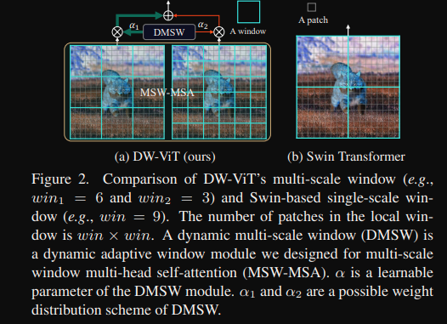

DW V.S. SwinT

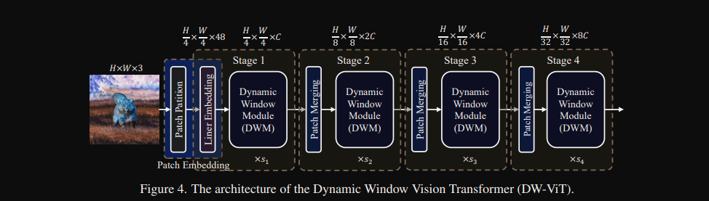

DW-Architecture

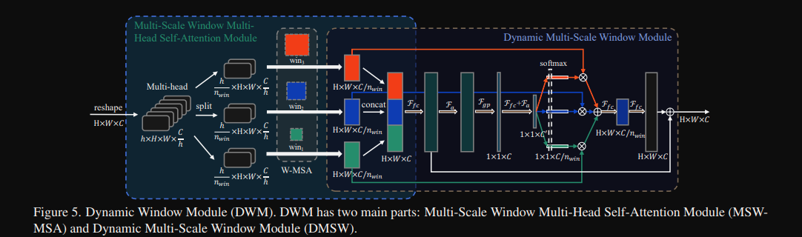

DW-Multiscale design

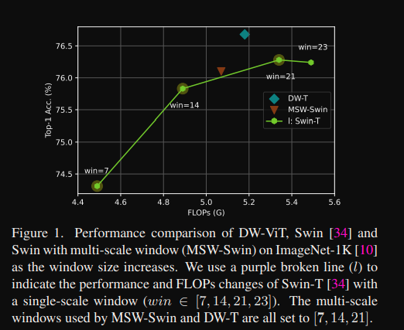

Performance better than SwinT

Review:

Incremental innovation on SwinT, add multi-scale anchor size for transformer.

Code: <https://github.com/pzhren/DW-ViT>

## Conclusion

Perception under BEV space has attracted a lot of attention from the research community and many famous EV car makers. It is worthwhile to explore the best way of utilizing this paradigm of technology in the development ADV project.

Among the many recently proposed methods, BEVFormer is the one to achieve a leading position on nuScenes leaderboard. The implementation is simple yet the performance is very promising compared to other models. We’ll select this model as our baseline to explore for 2 major issues, how to detect small objects from input and how to compress the model size while maintaining good performance.